Electricity Dataset Visualation

# Foley_2020.csv

Entire_Dataset_Plot.png

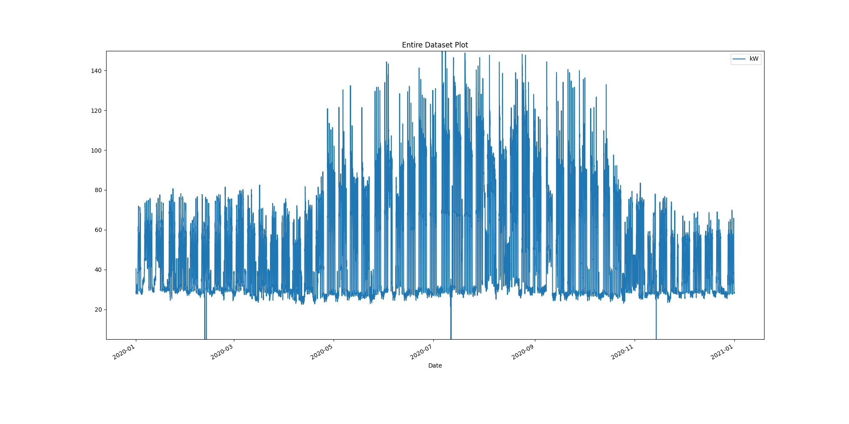

# Plot of month with max demand recorded

Month_maximum_recorded_demand.png

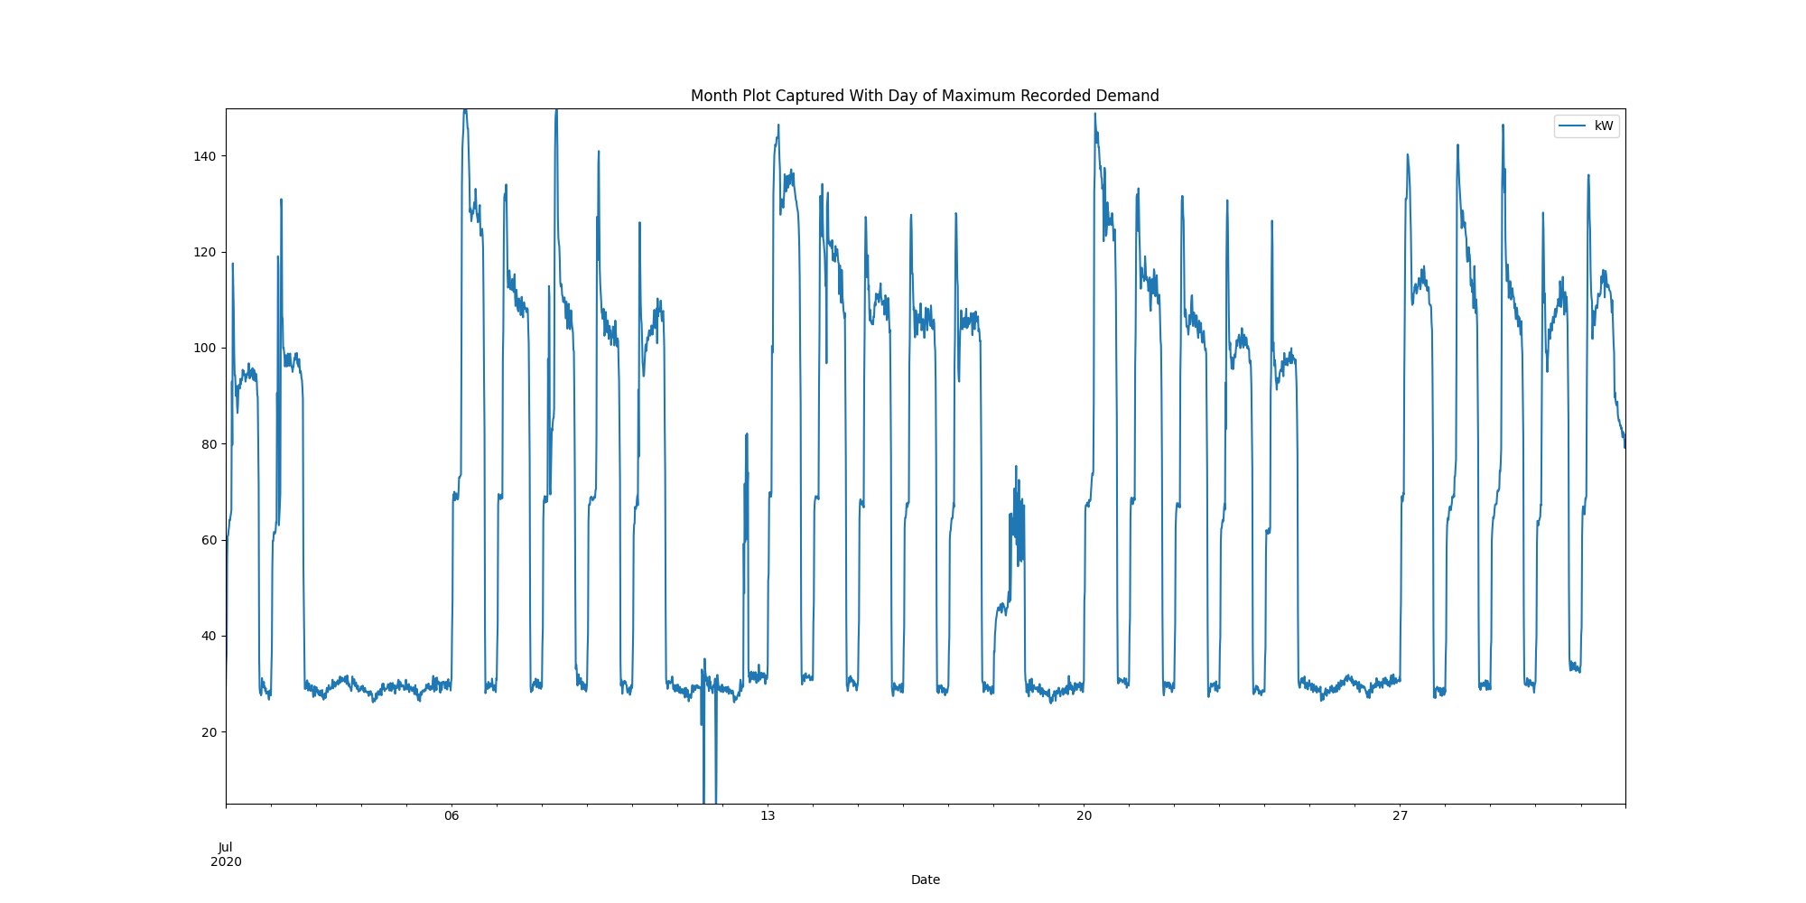

# Power box plots per month

AllDatakWboxPlots.png

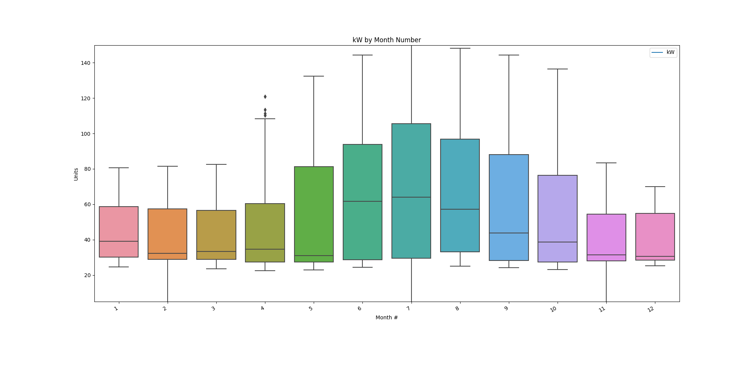

# Power consumption trends

kWtrendsPlot.png

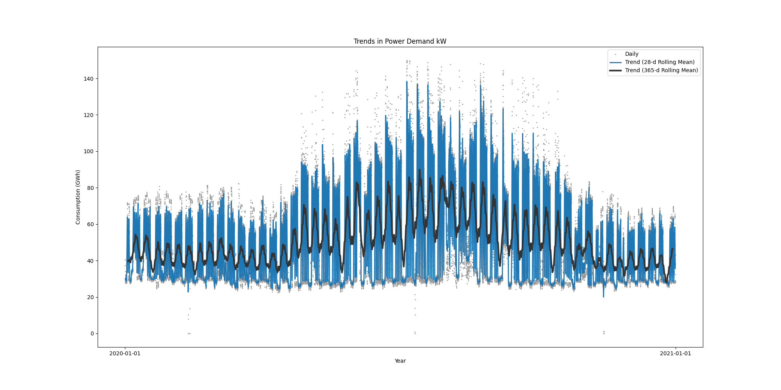

Data Analysis Report Winter

Winter Months Electrical Load Profiles

datasetPlot.png

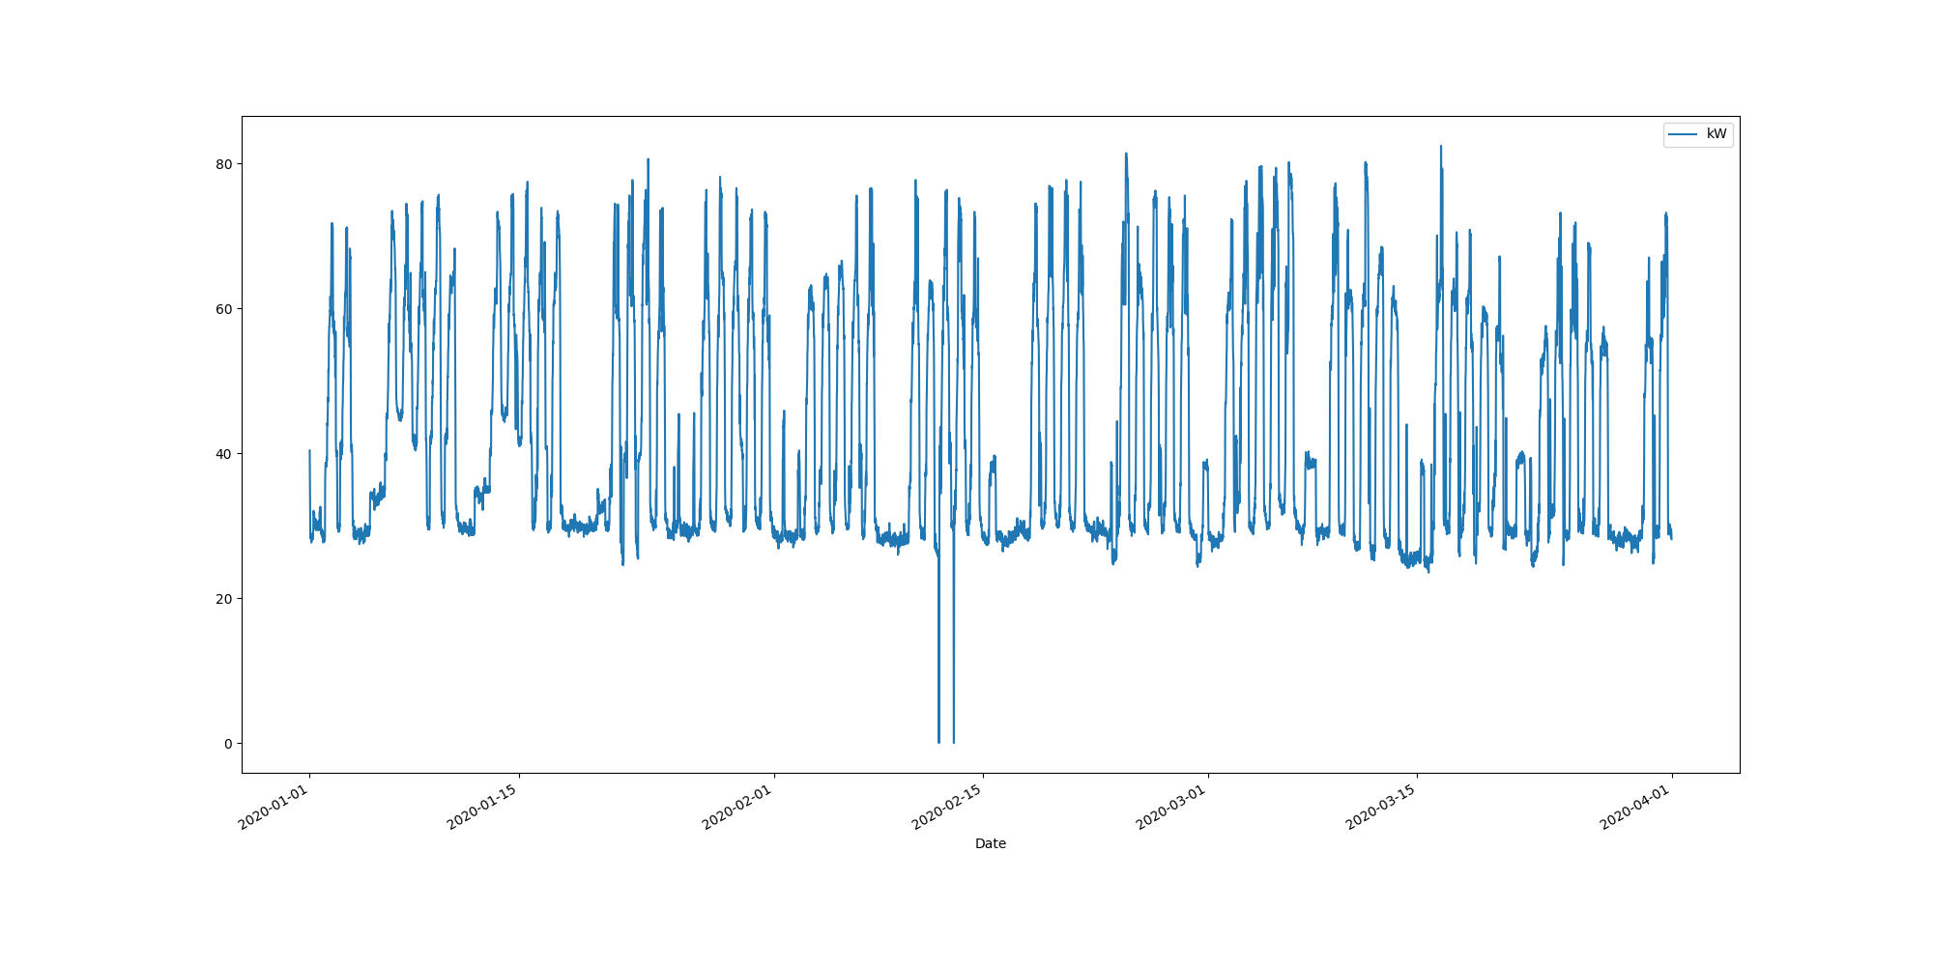

# Max Demand Found In Dataset

kW 82.463  
Name: 2020-03-16 14:00:00, dtype: float64

# Dataset Summary Statistics

kW  
count 8732.000000  
mean 42.642504  
std 15.709433  
min 0.000000  
25% 29.362000  
50% 34.650000  
75% 57.713000  
max 82.463000

# Highest Ranked Change Point Algorithm Detection

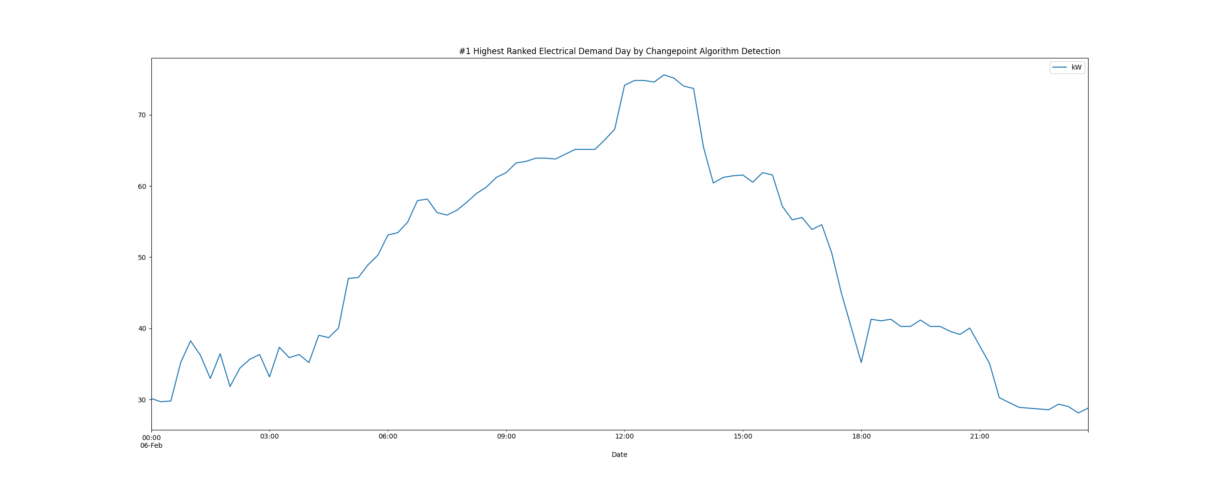

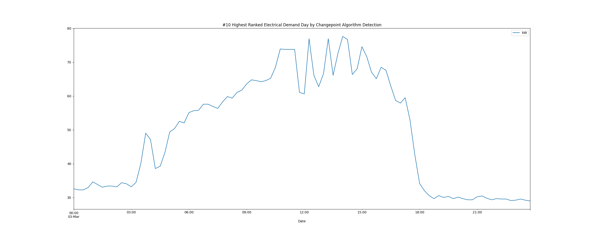

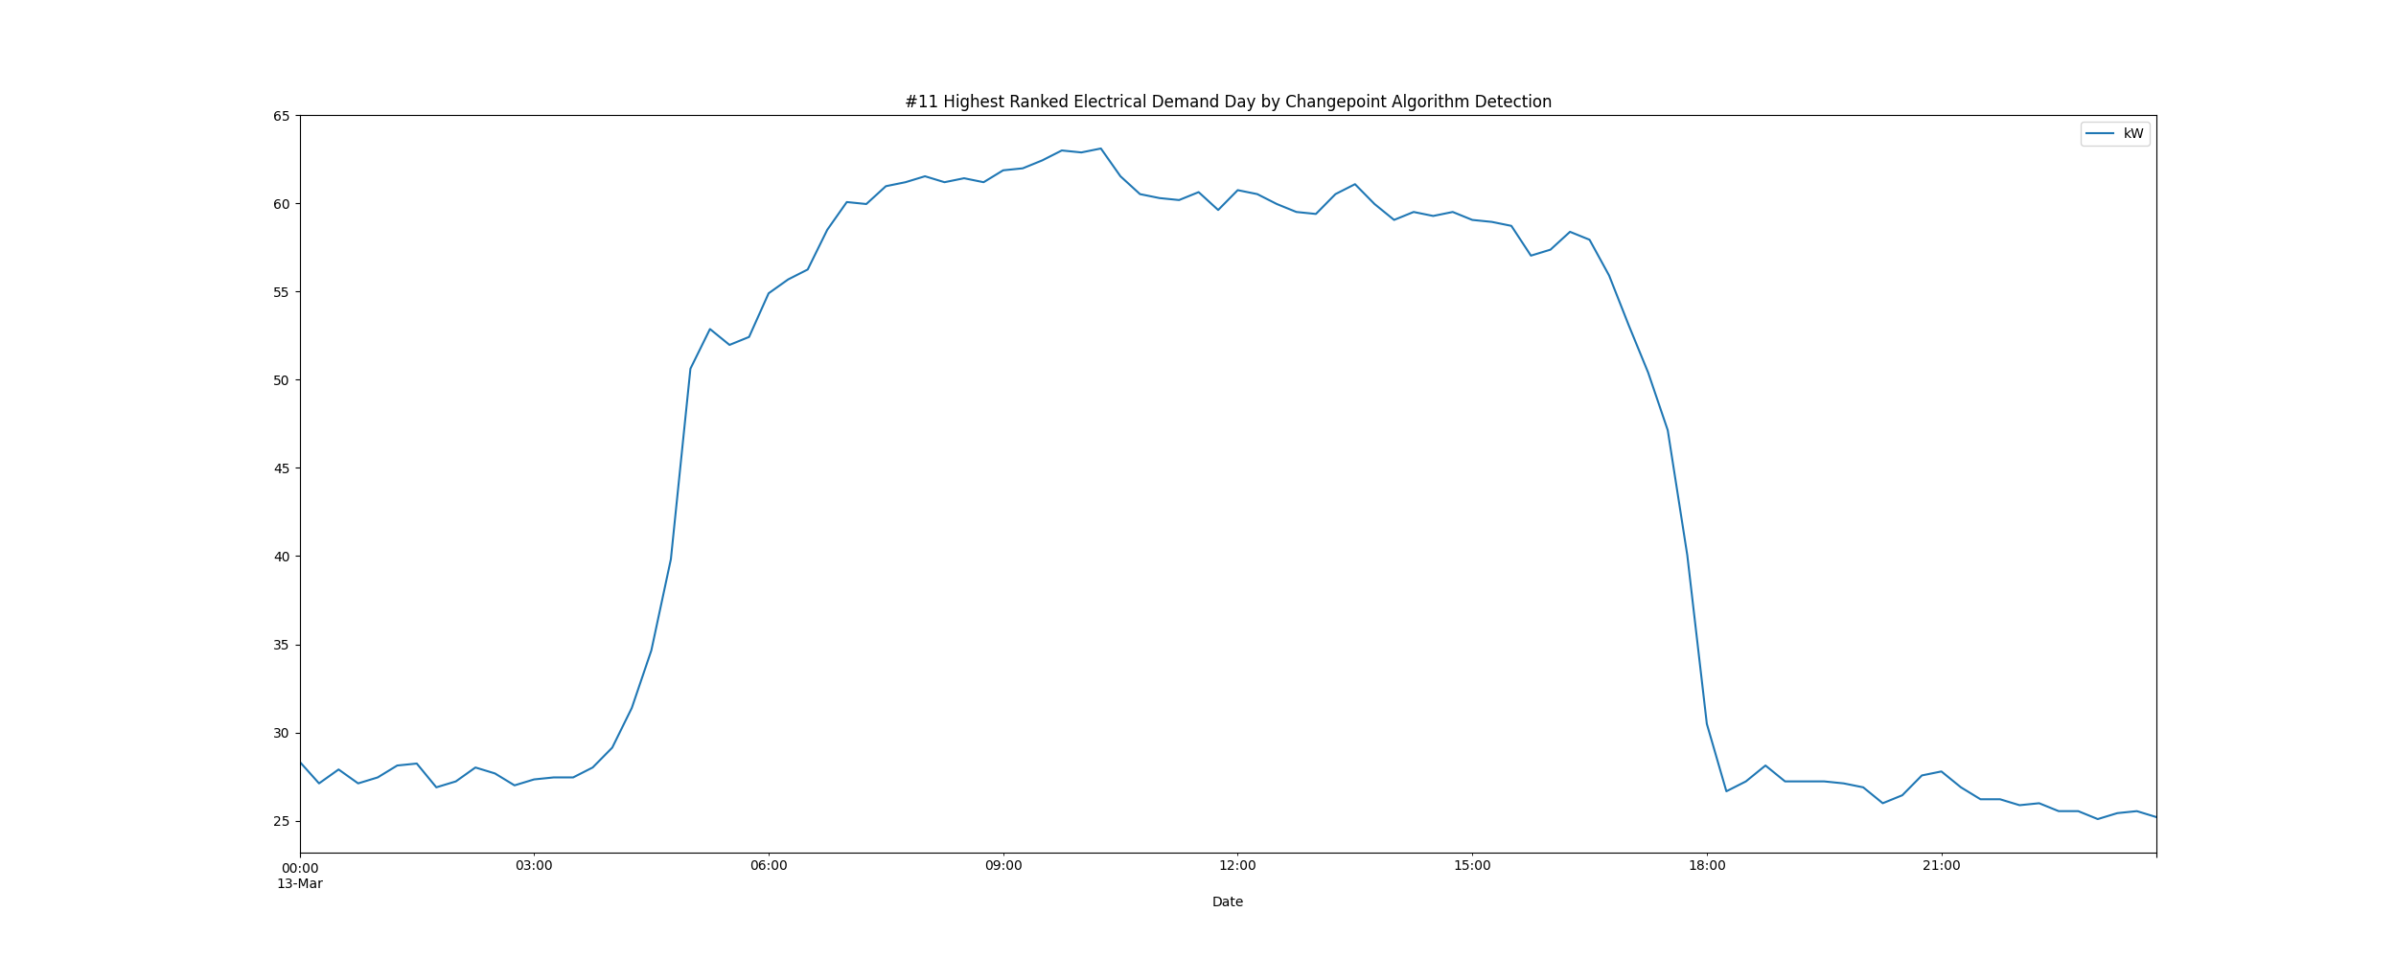

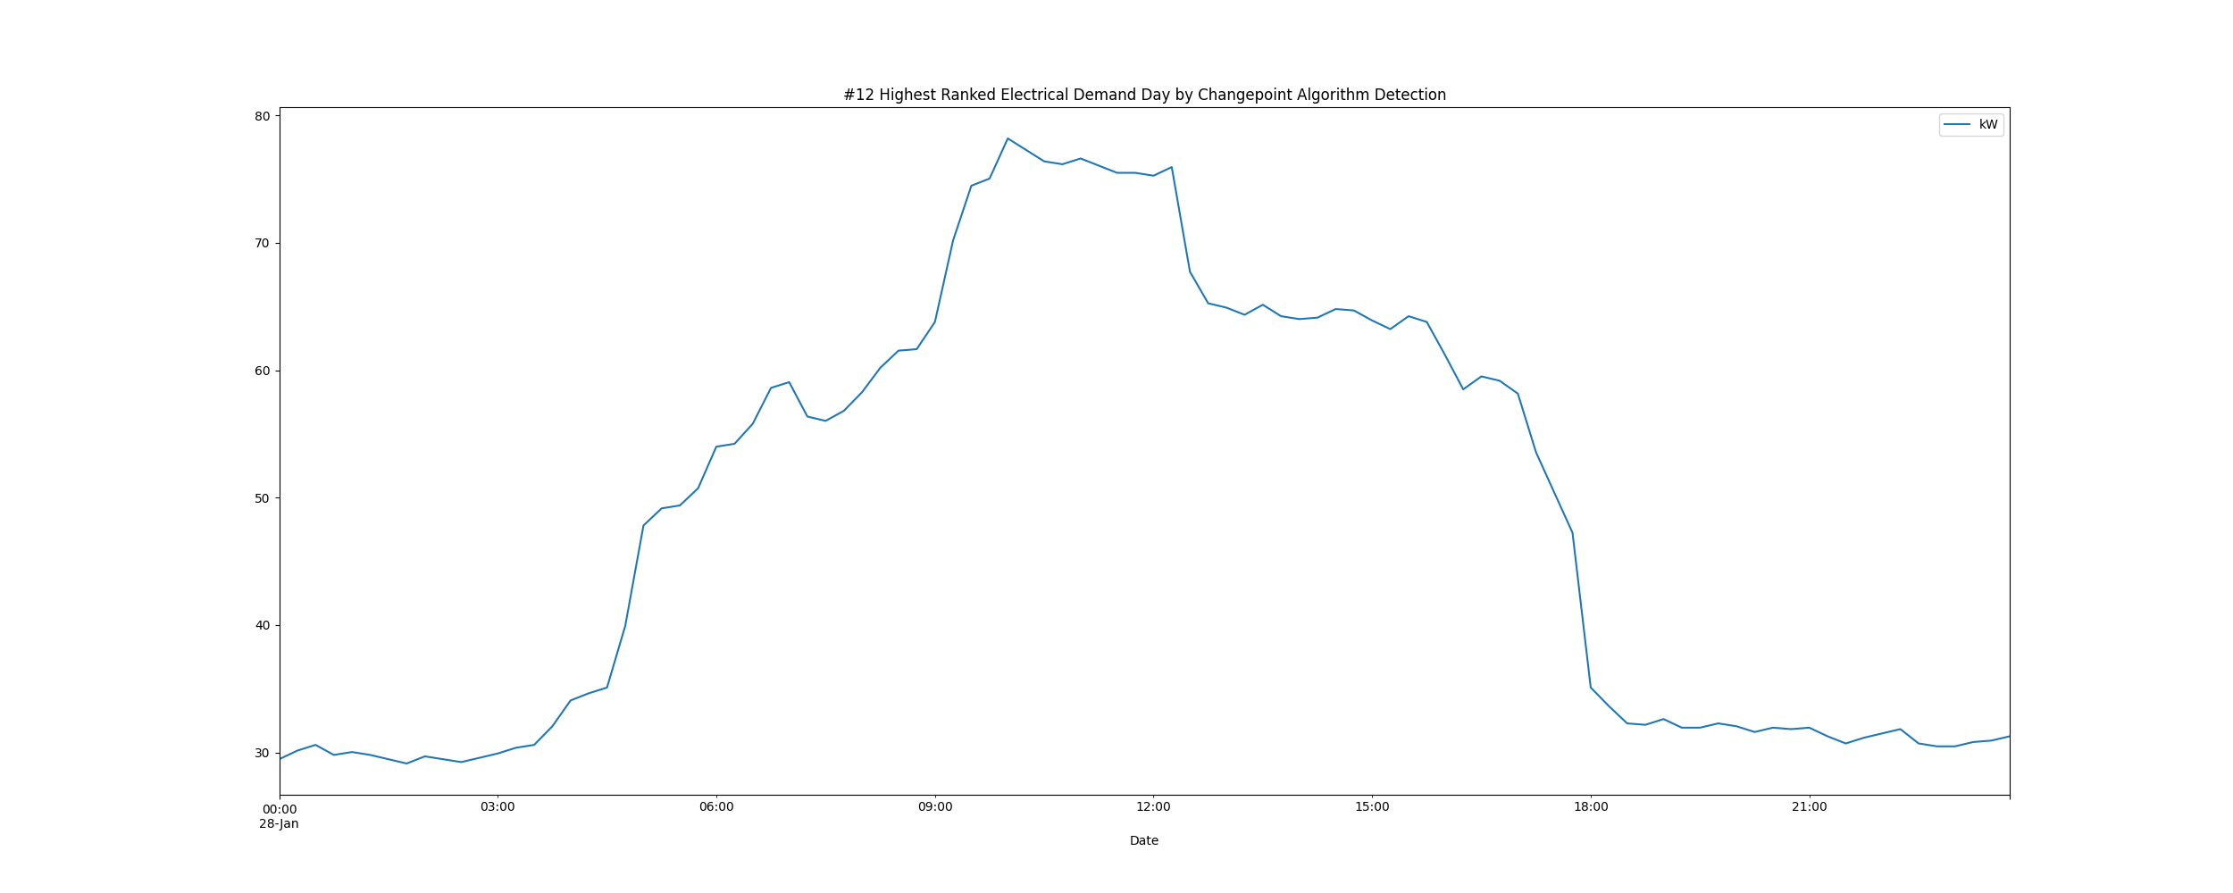

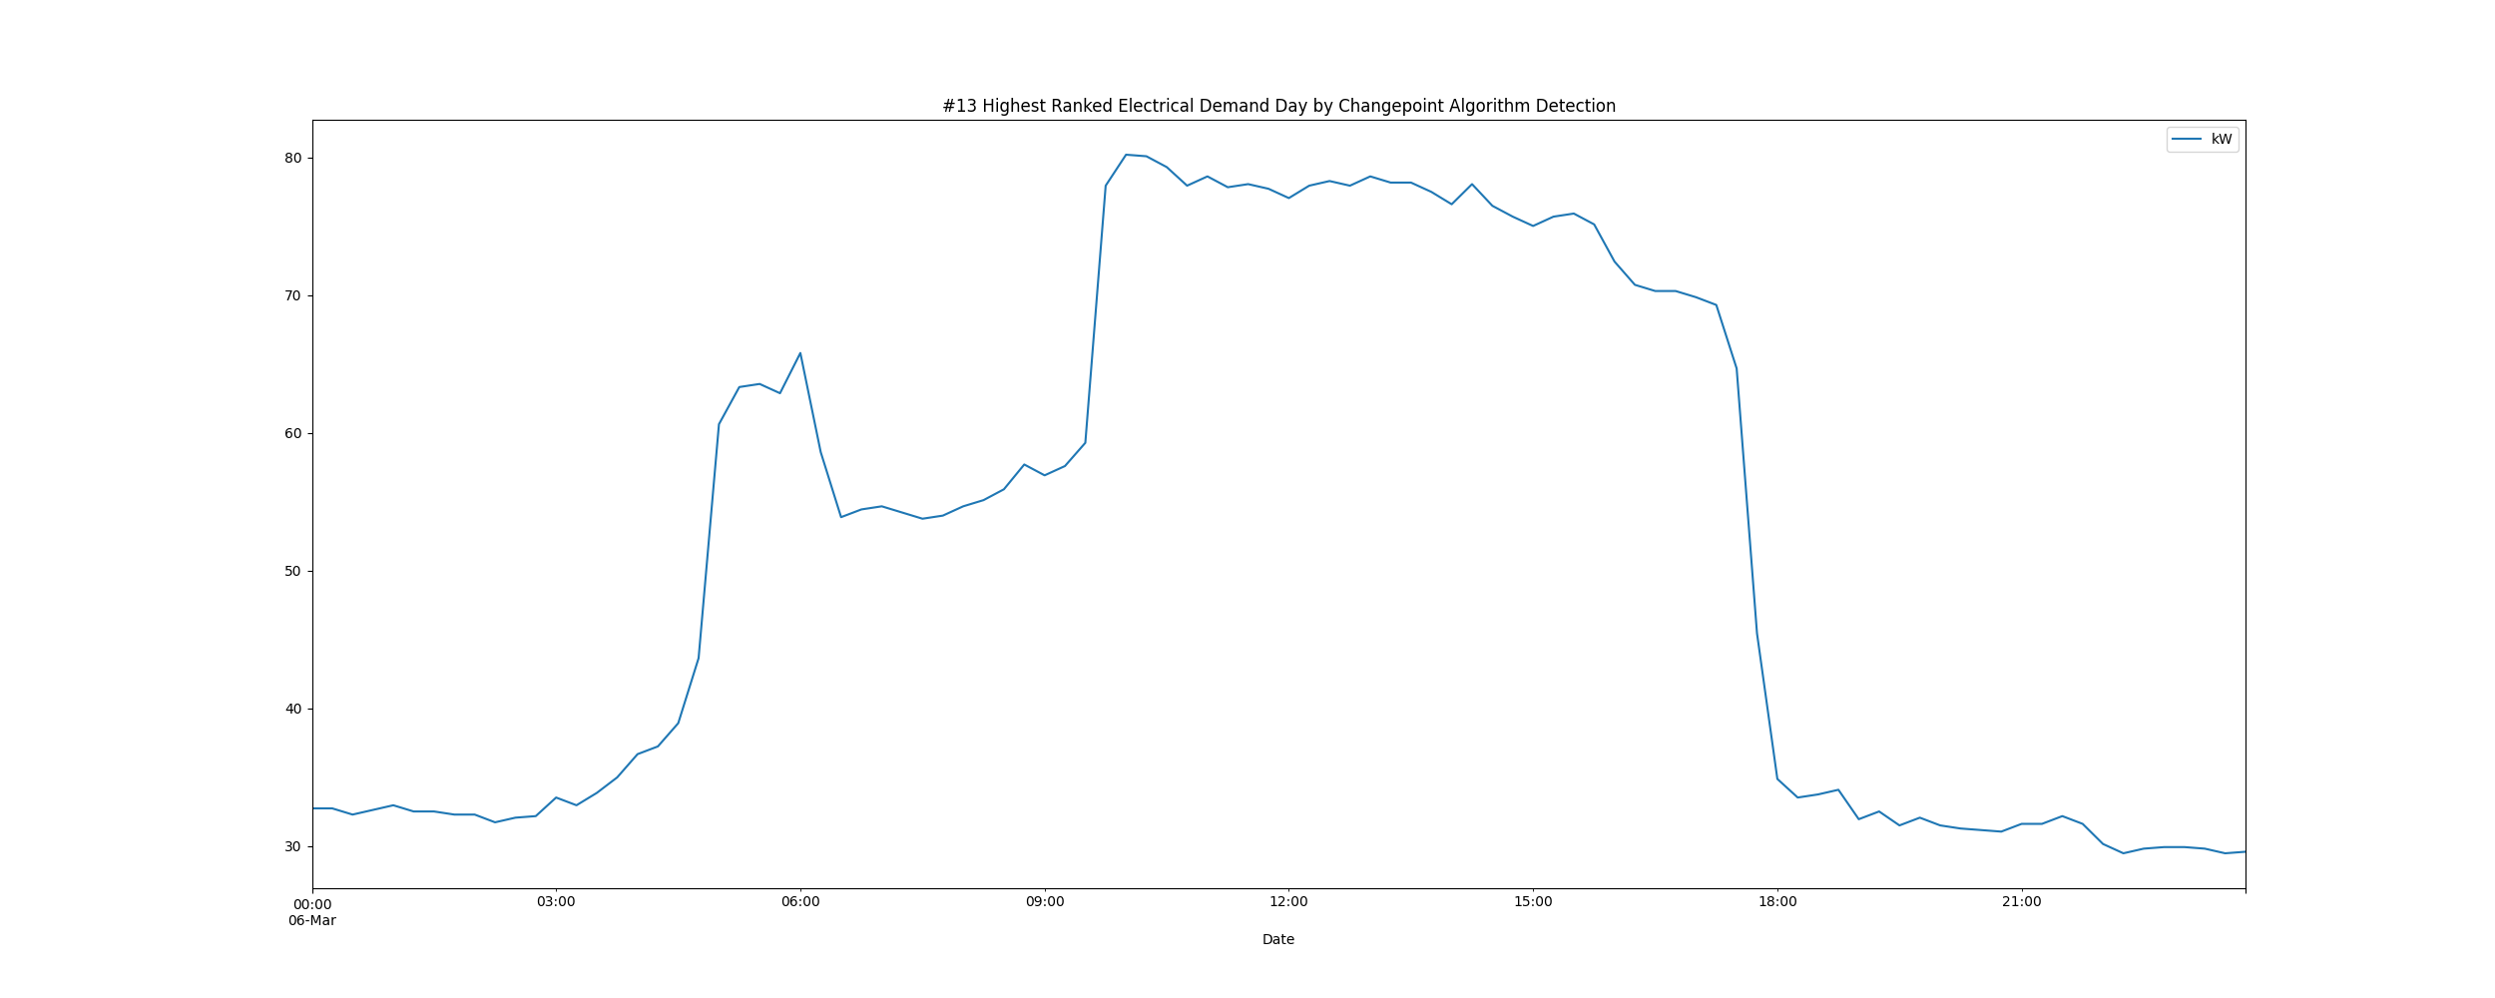

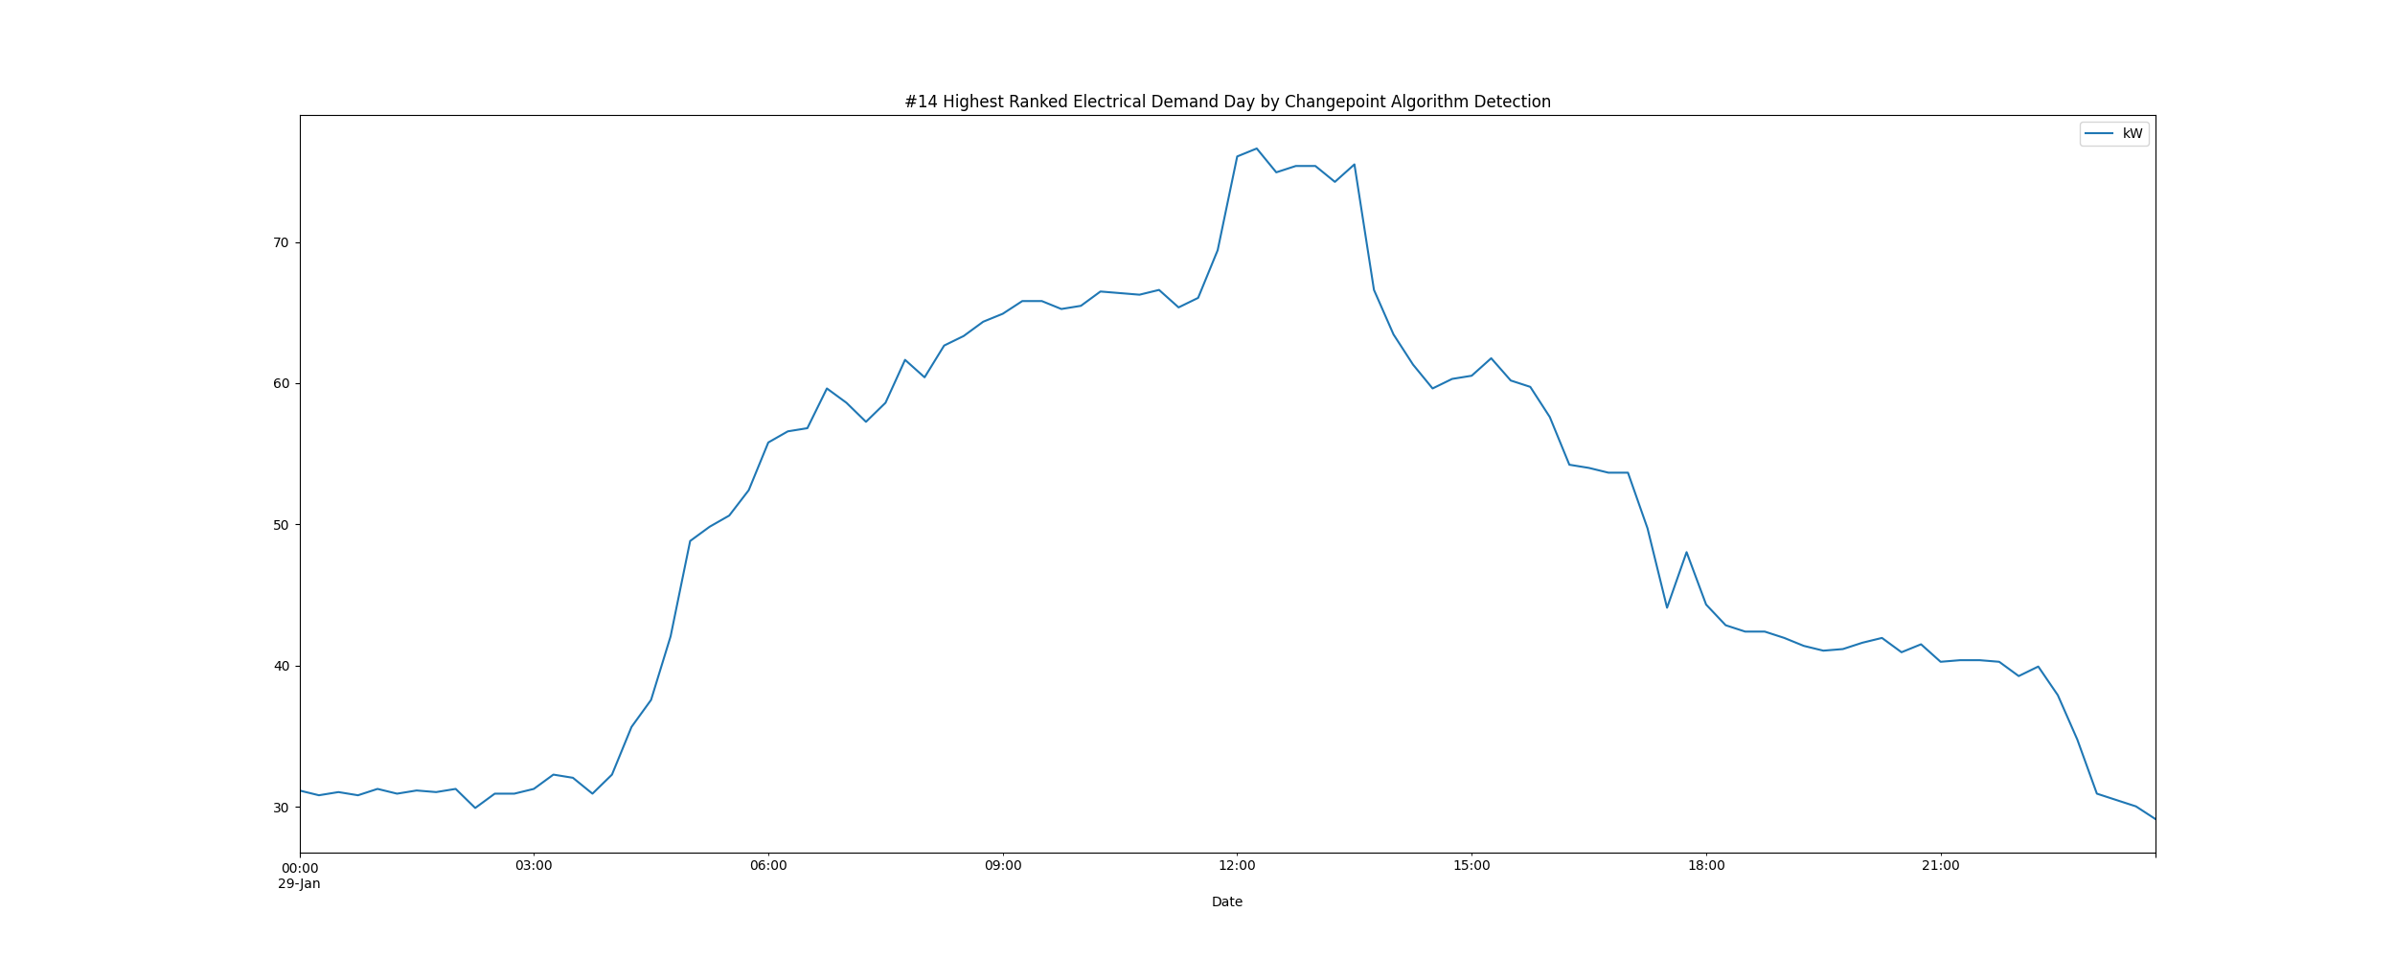

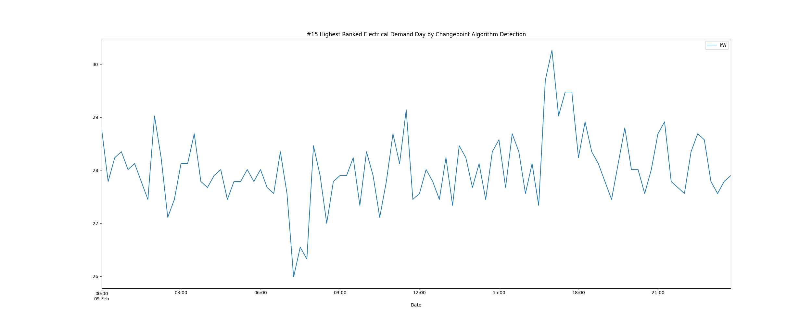

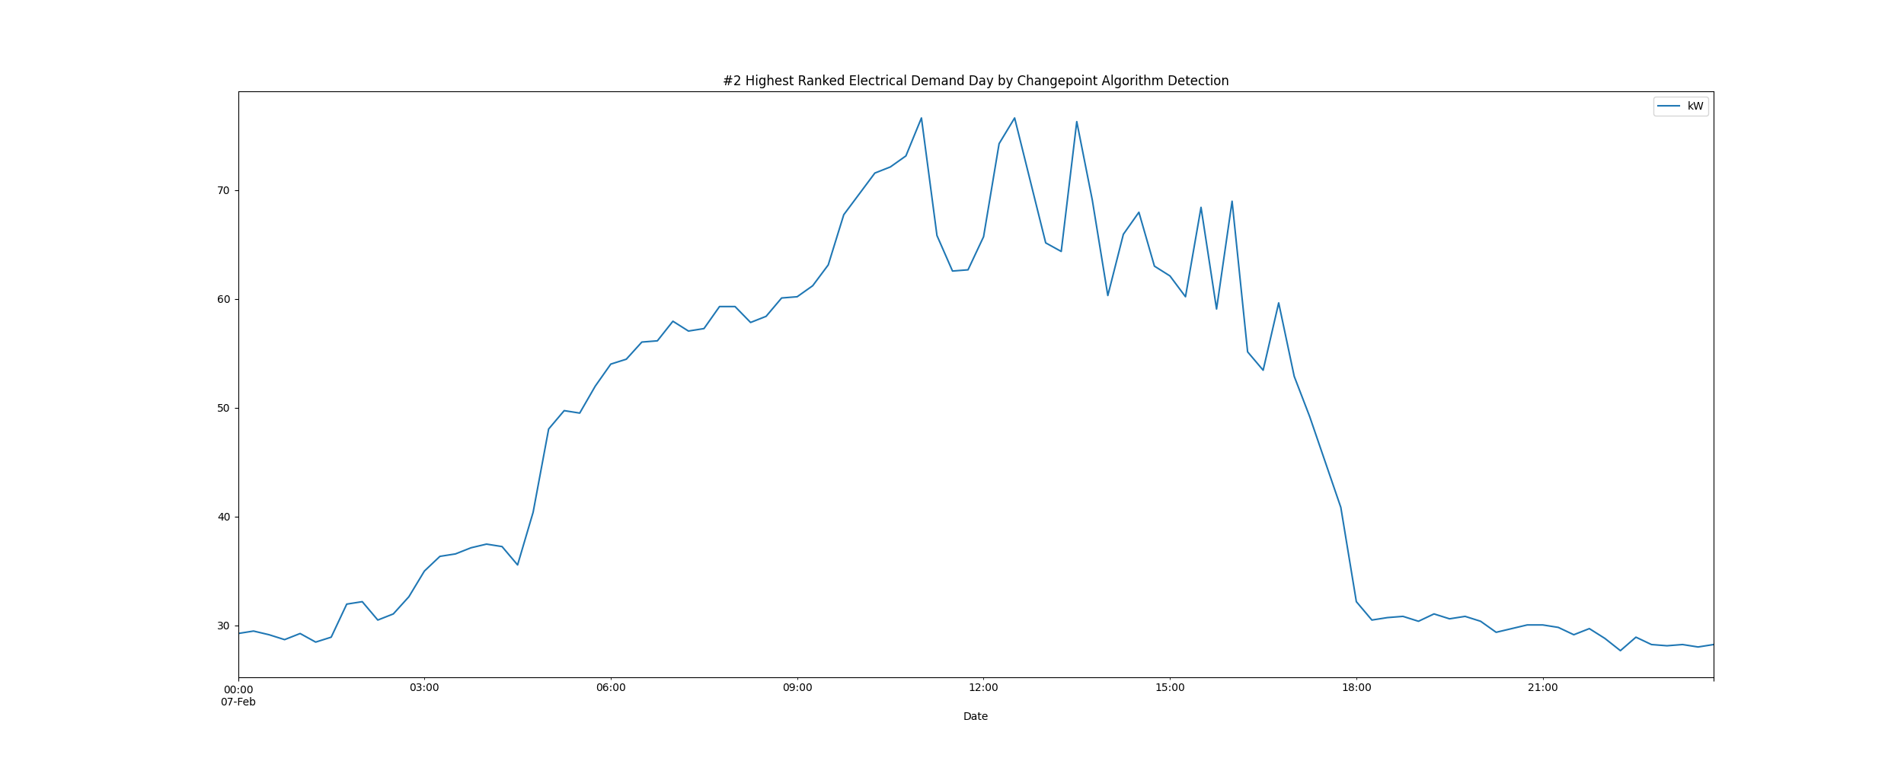

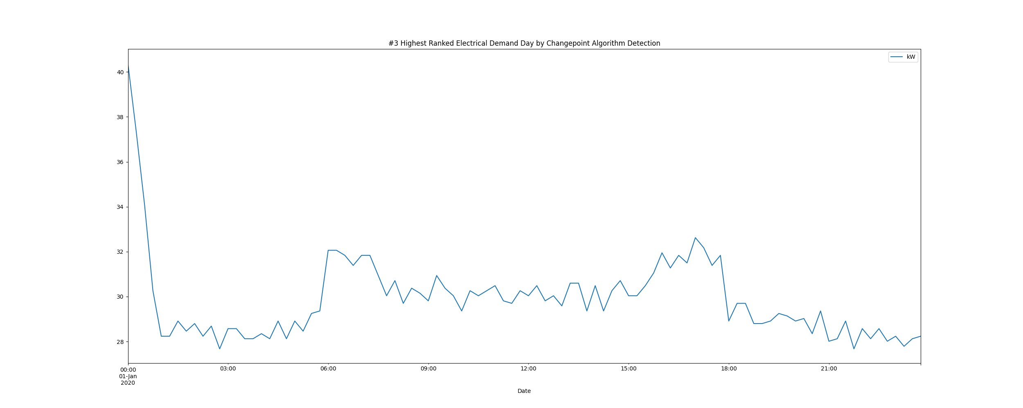

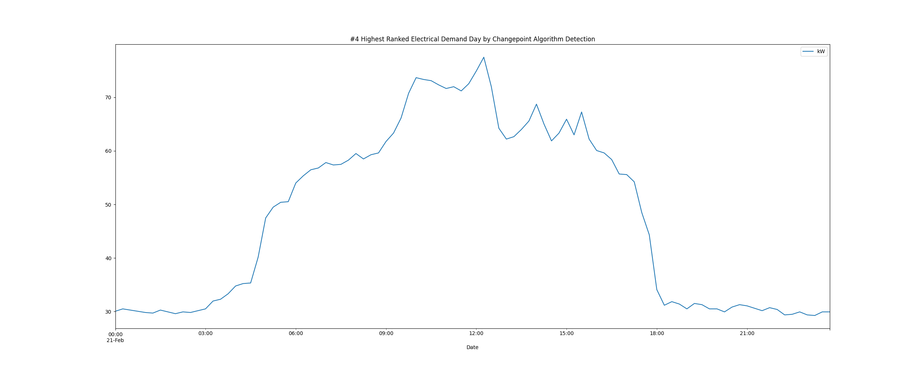

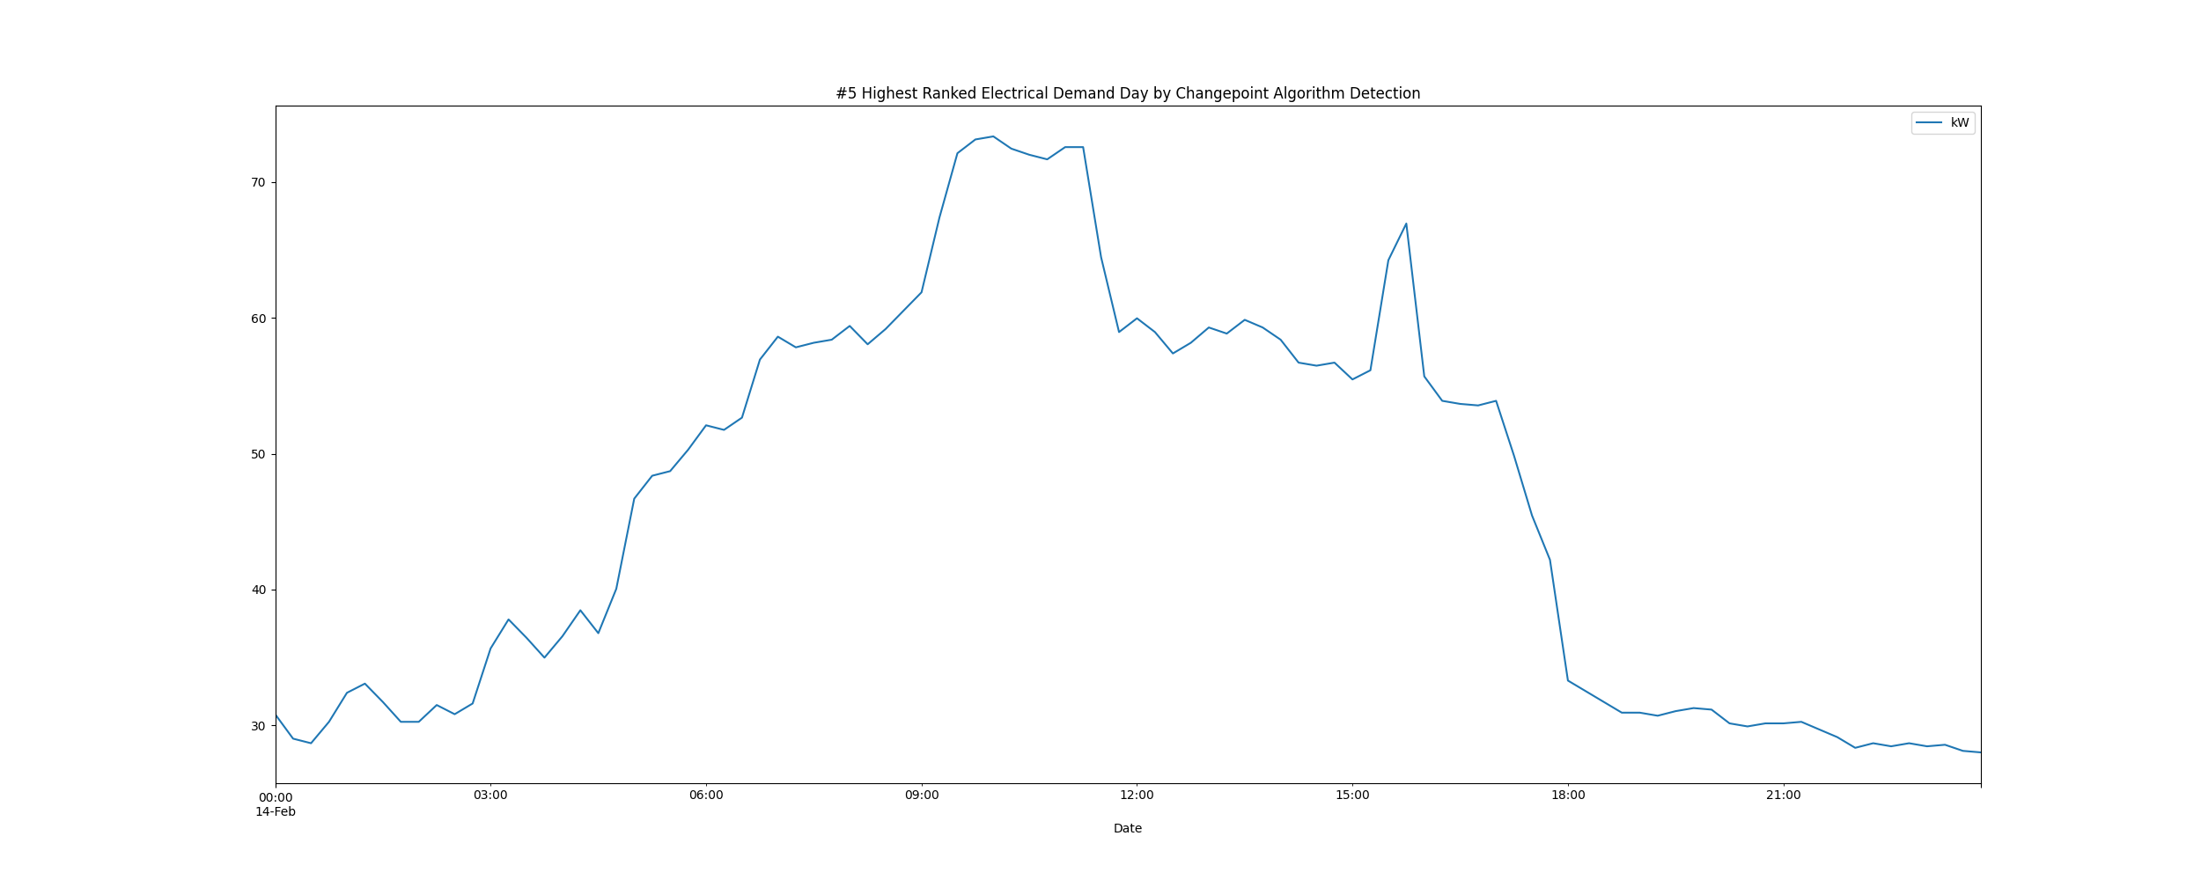

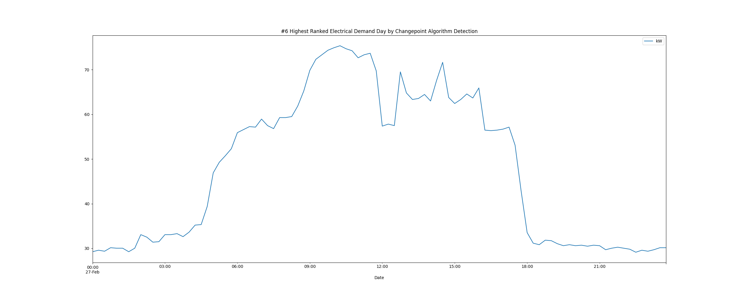

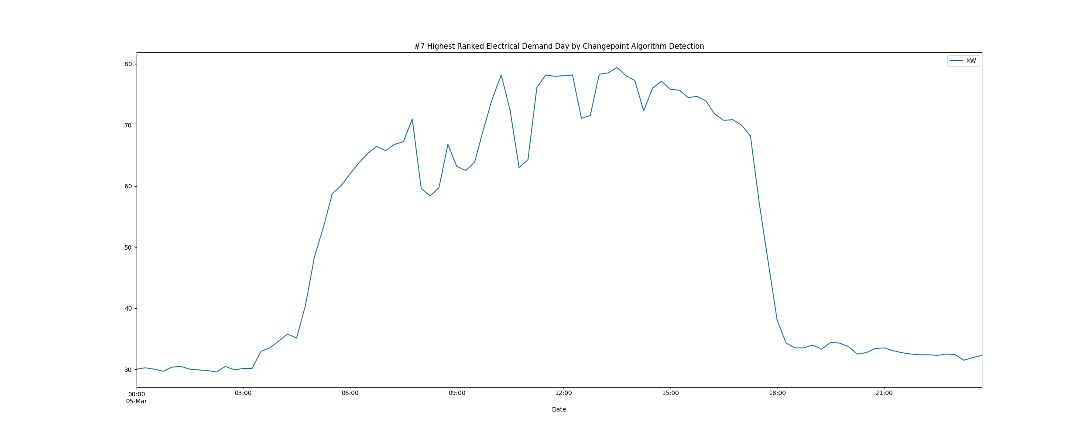

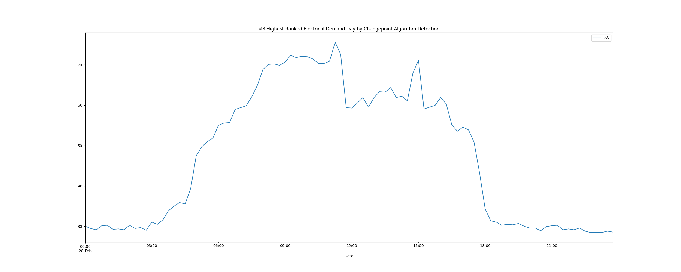

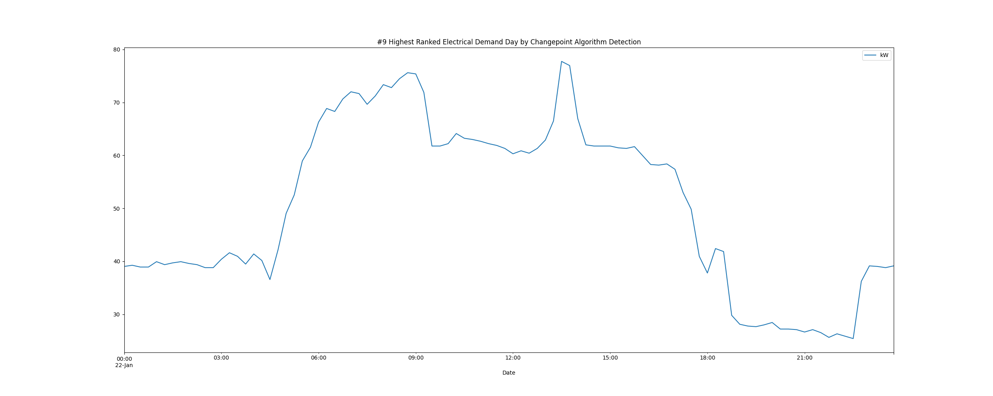

# Daily High and Low Load kW Values

highLowLoadsPlot.png

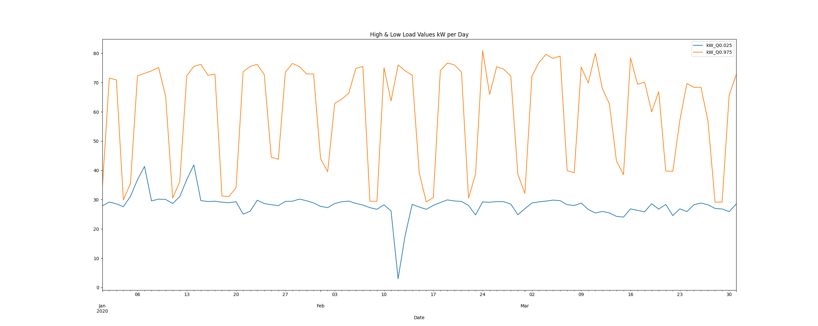

# Max Demand and Hour of Day Plot

Max_Demand_and_Max_Hour_of_Day.png

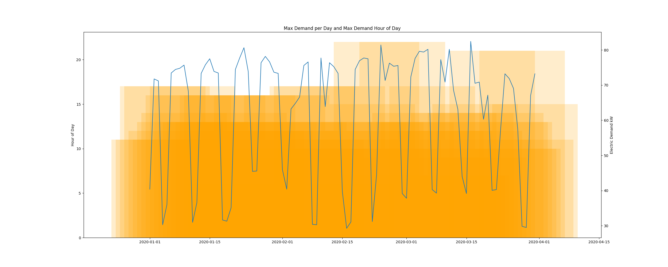

* Resampling the interval dataset to calculate units of energy KWh/day, the first day is 2020-01-01 and the last day is 2020-03-31
* Total days in dataset 90 days
* Total Sum of calculated electrical energy 93049.77582857144 kWh

# kWh Rolling 7 Day Avg

kWhRollingAvg.png

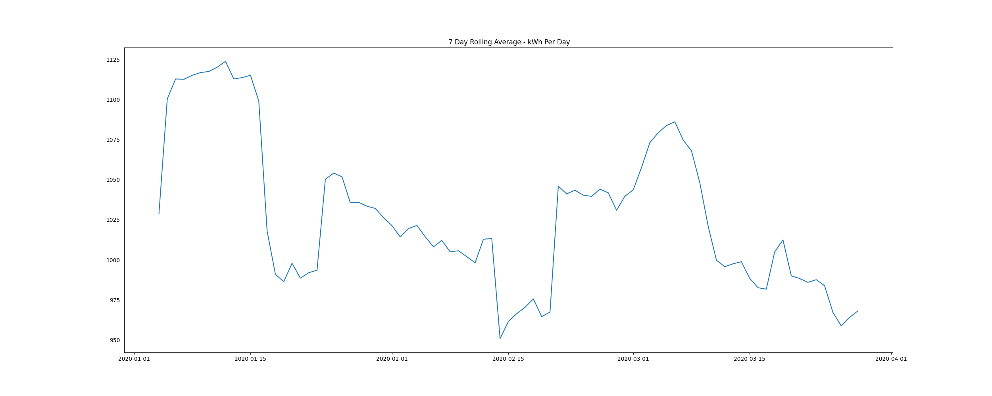

# Demand Plots By Month

Demands_for_Winter_Month_February.png

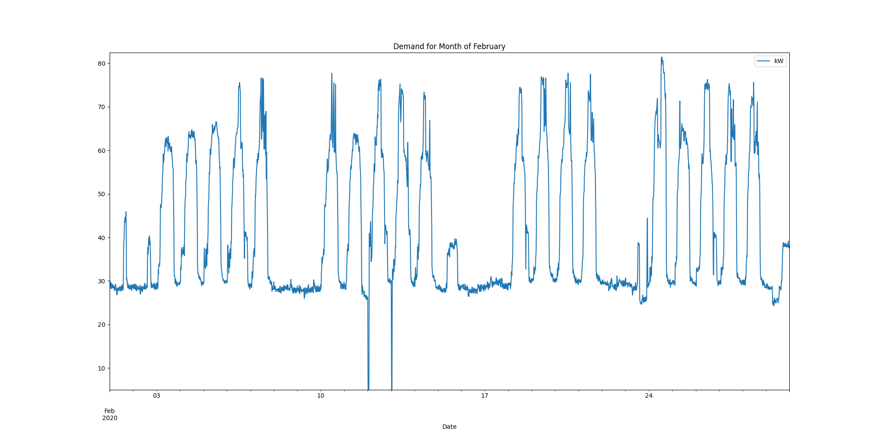

Demands_for_Winter_Month_January.png

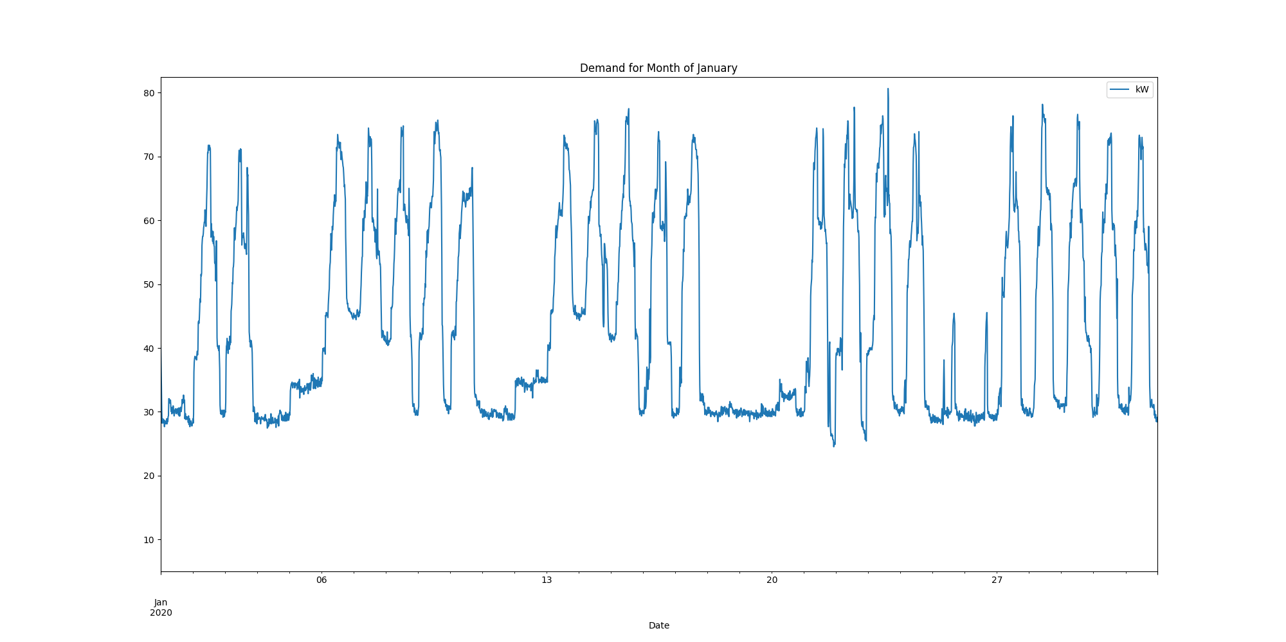

Demands_for_Winter_Month_March.png

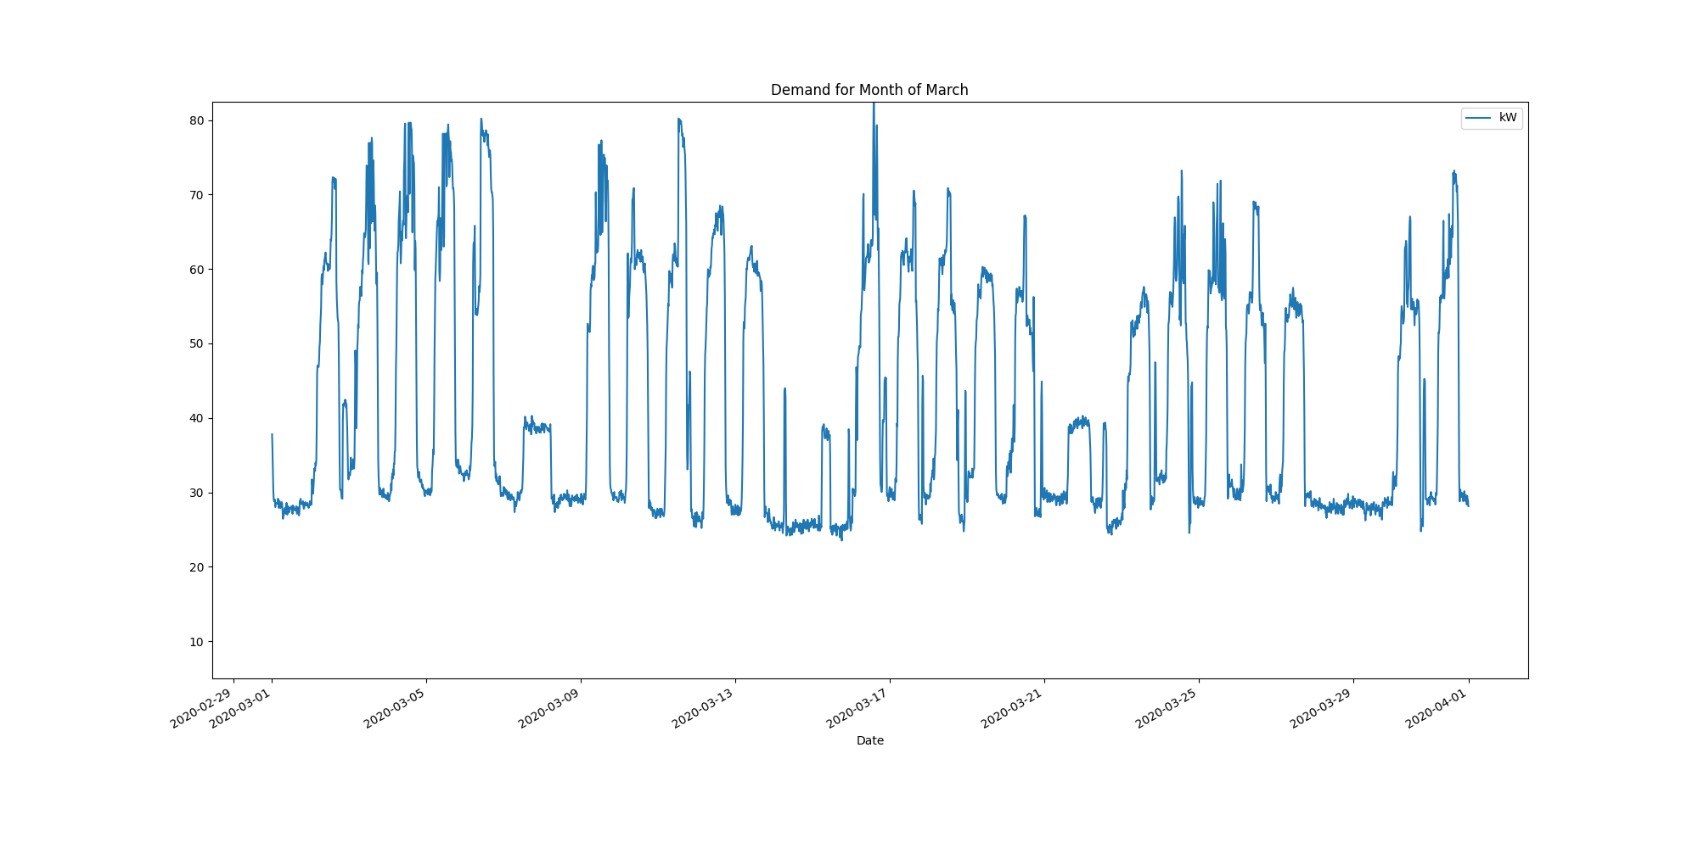

Data Analysis Report Summer

Summer Months Electrical Load Profiles

datasetPlot.png

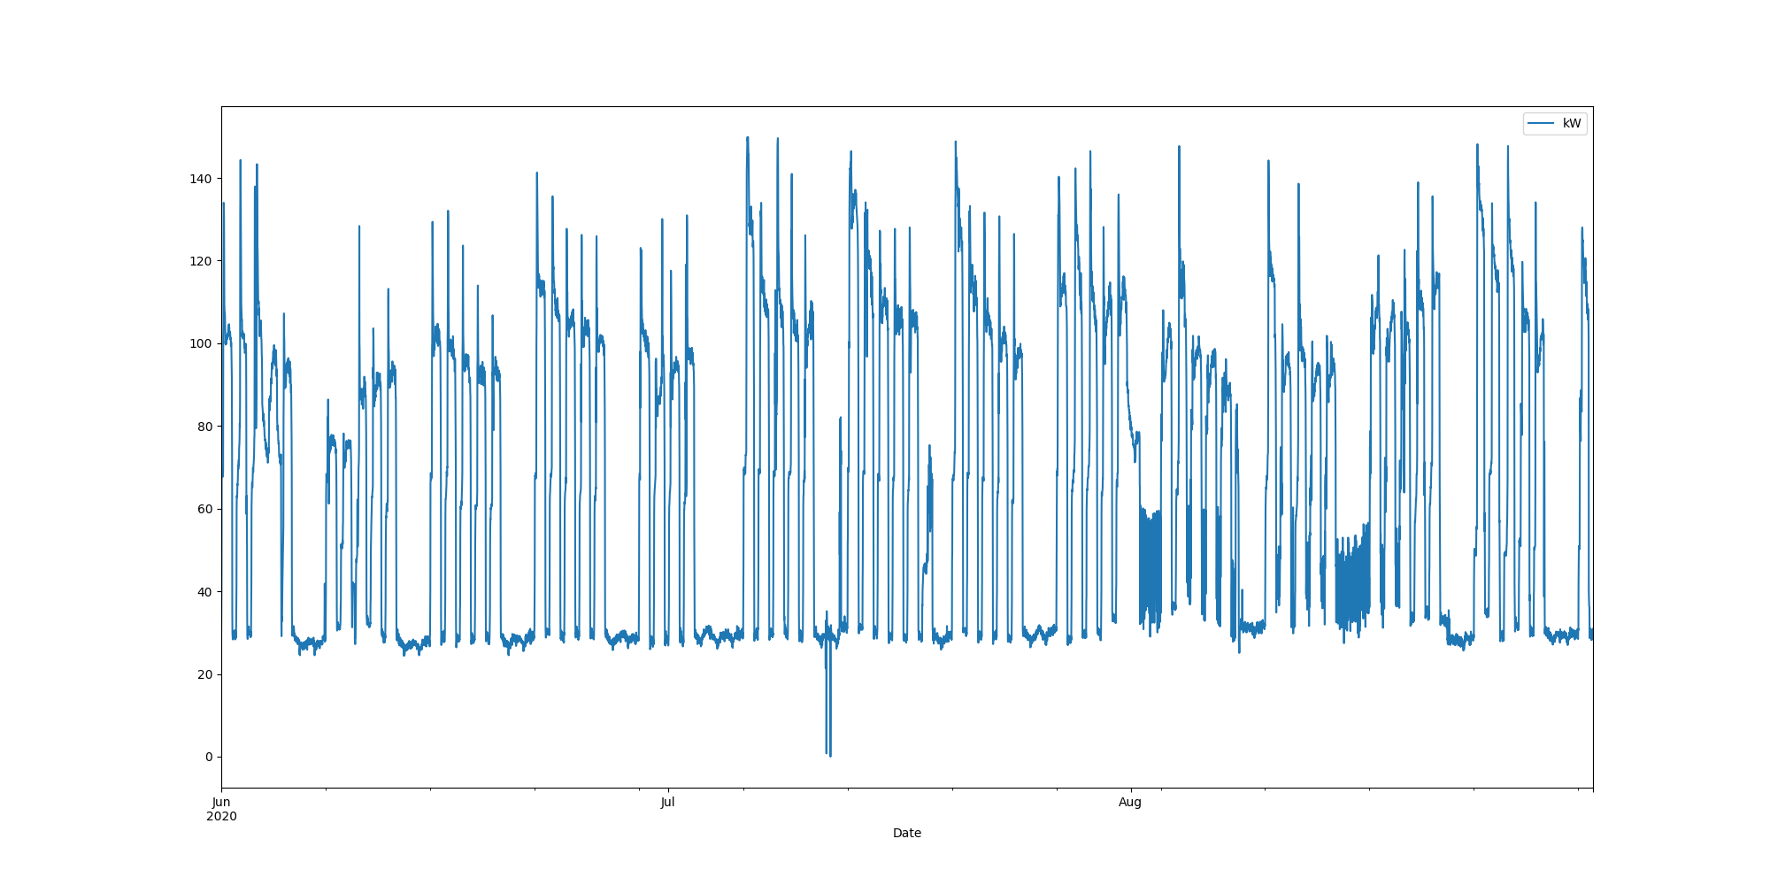

# Max Demand Found In Dataset

kW 149.85  
Name: 2020-07-06 06:45:00, dtype: float64

# Dataset Summary Statistics

kW  
count 8832.000000  
mean 65.149142  
std 35.294588  
min 0.000000  
25% 29.700000  
50% 60.412000  
75% 98.550000  
max 149.850000

# Highest Ranked Change Point Algorithm Detection

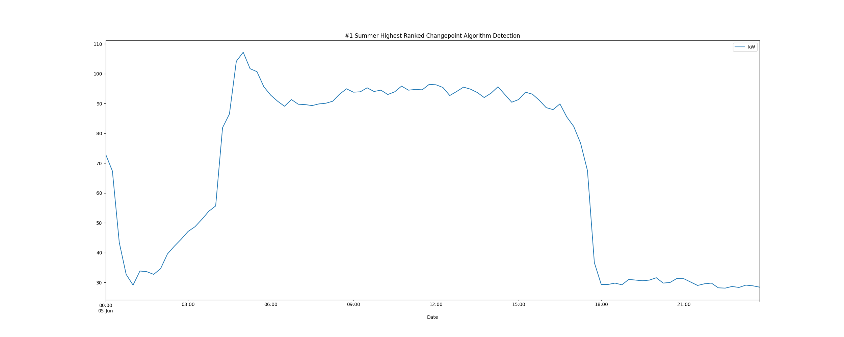

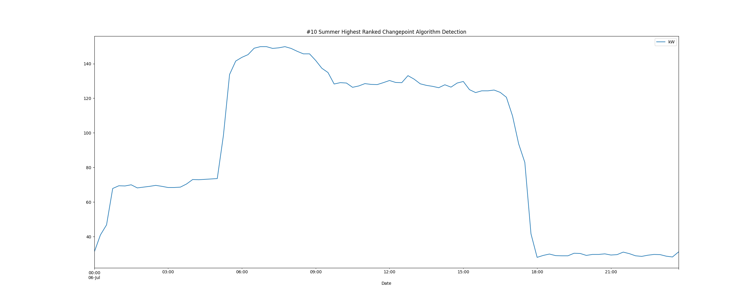

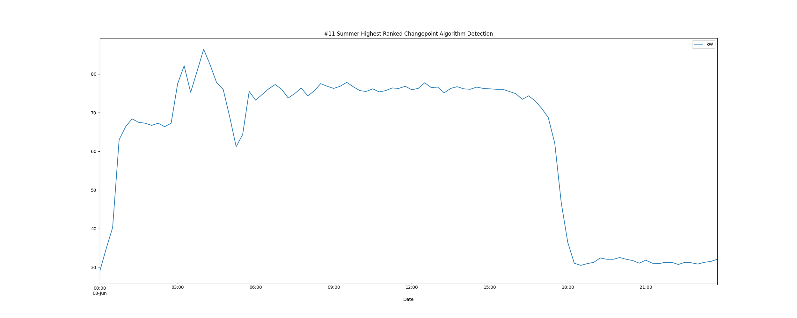

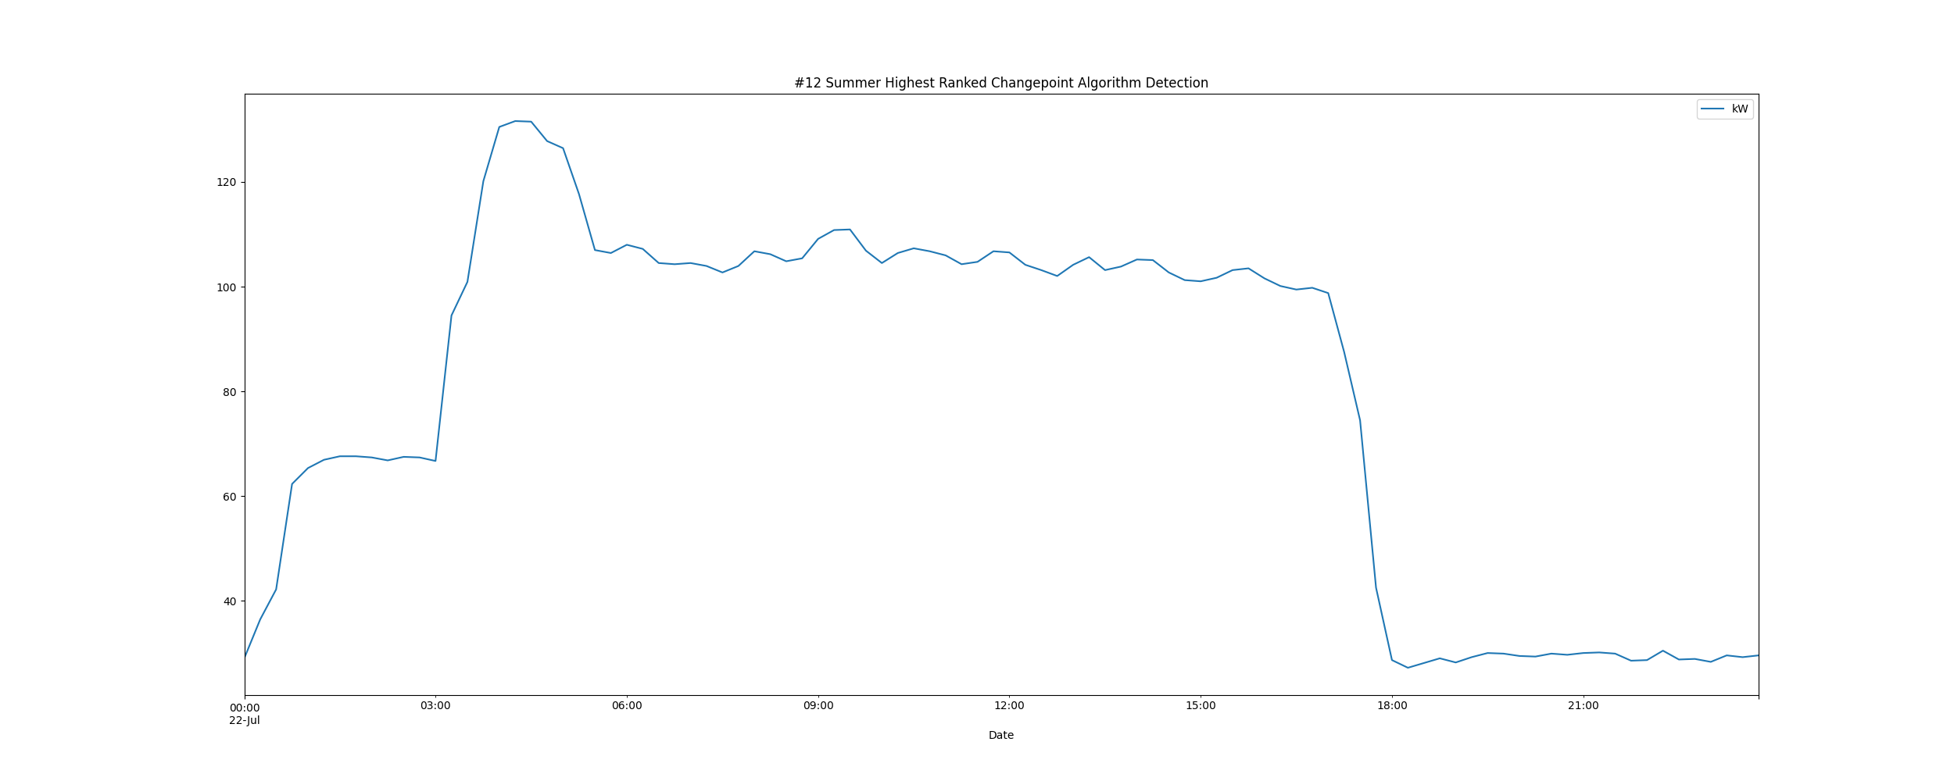

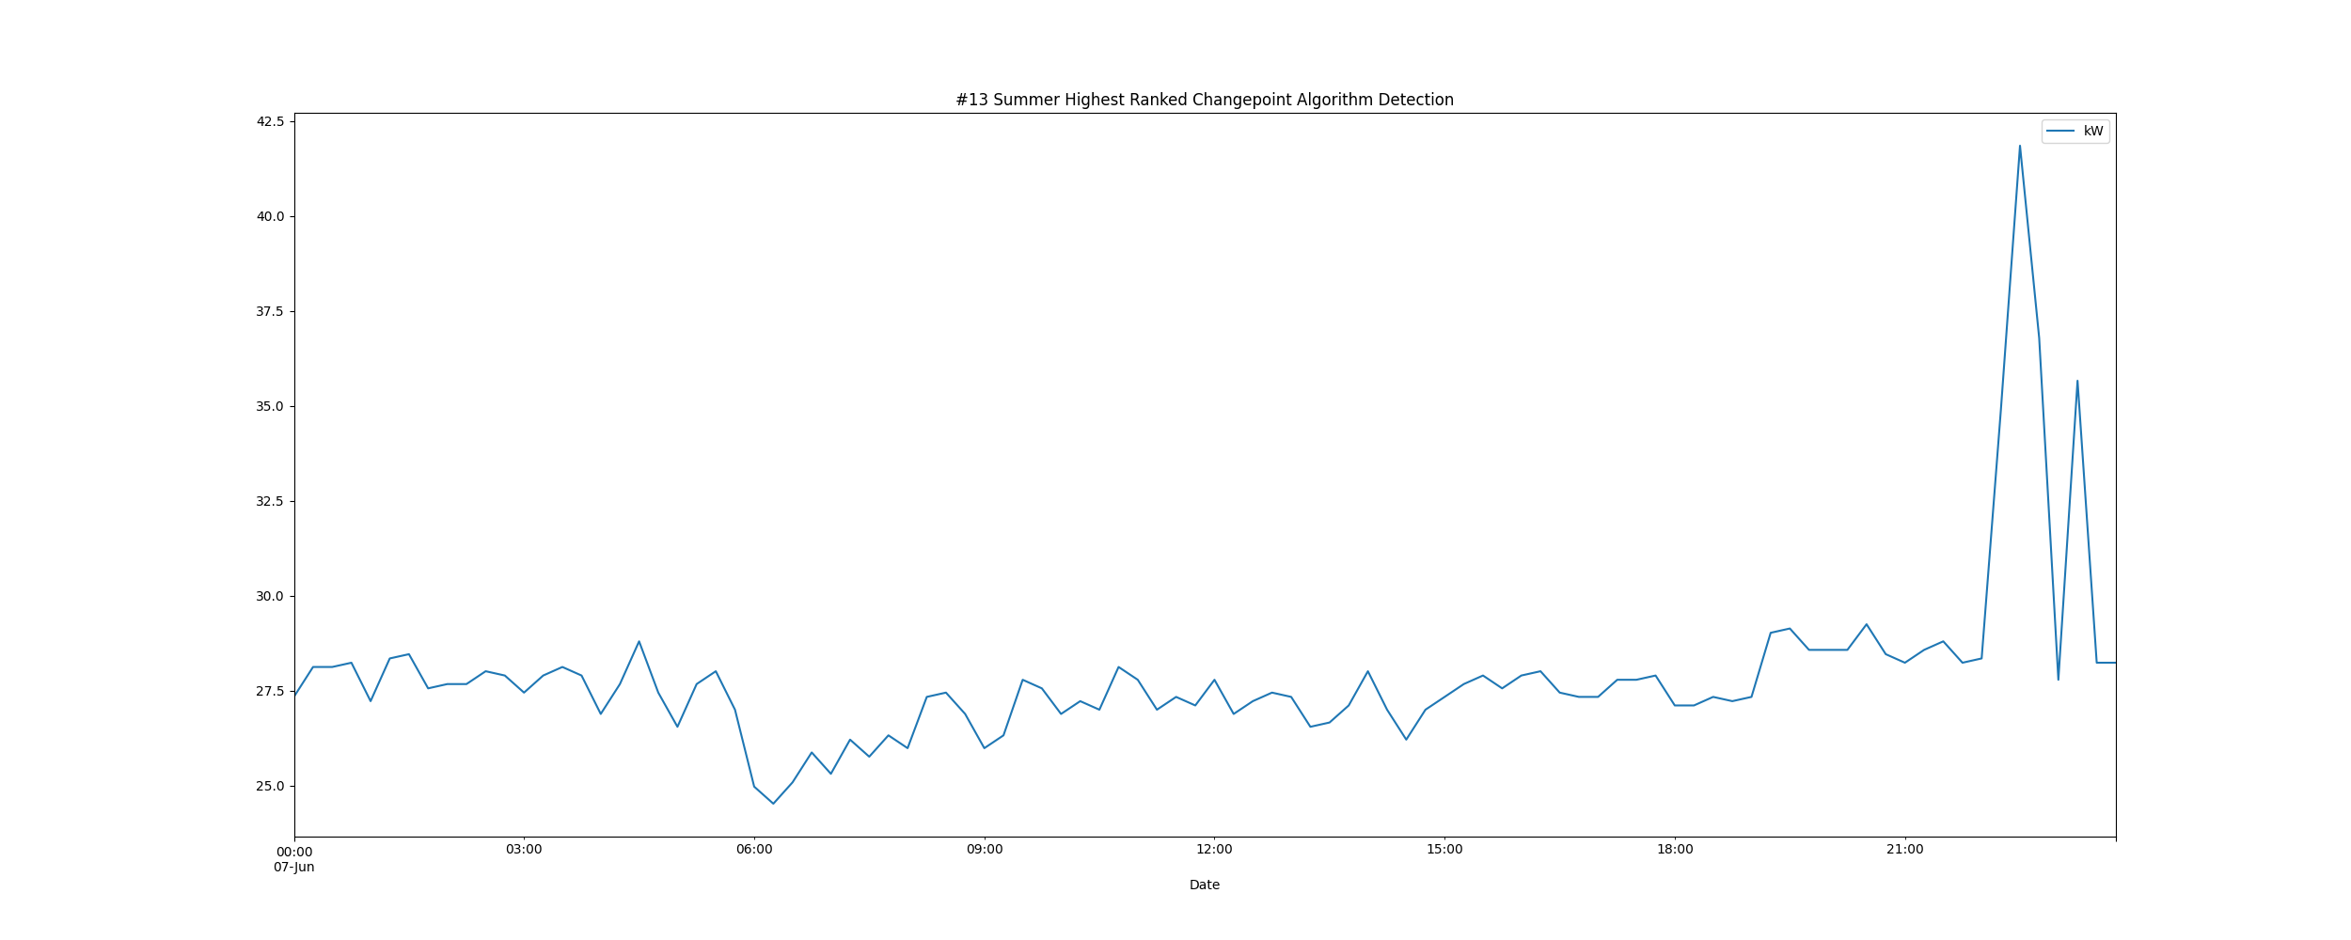

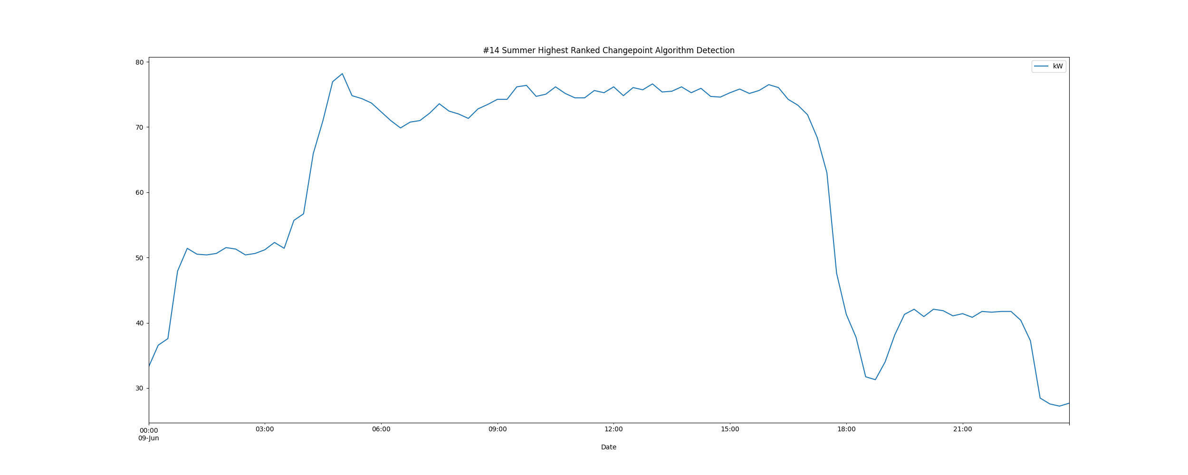

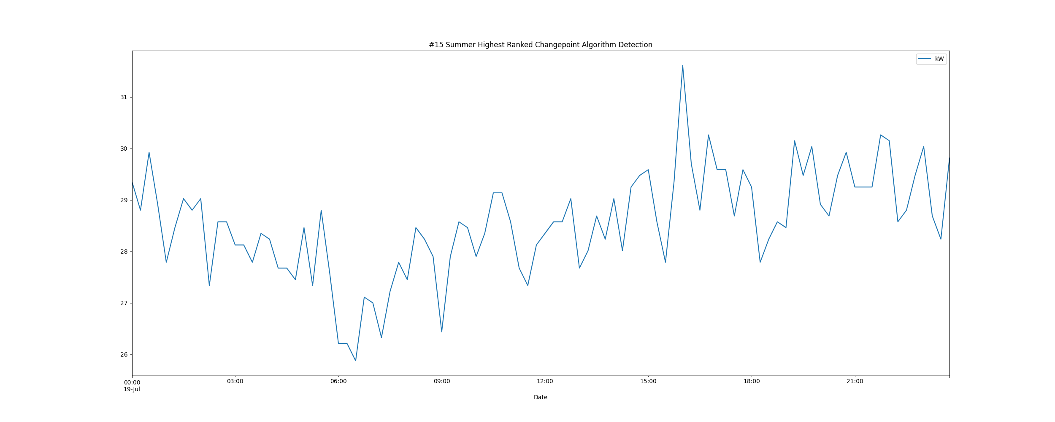

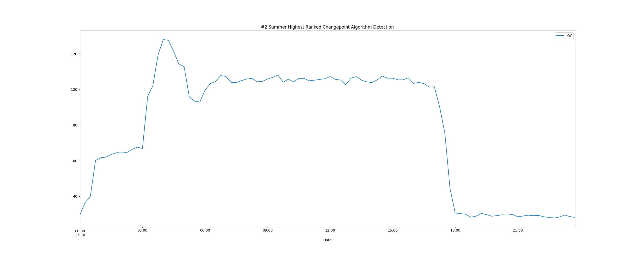

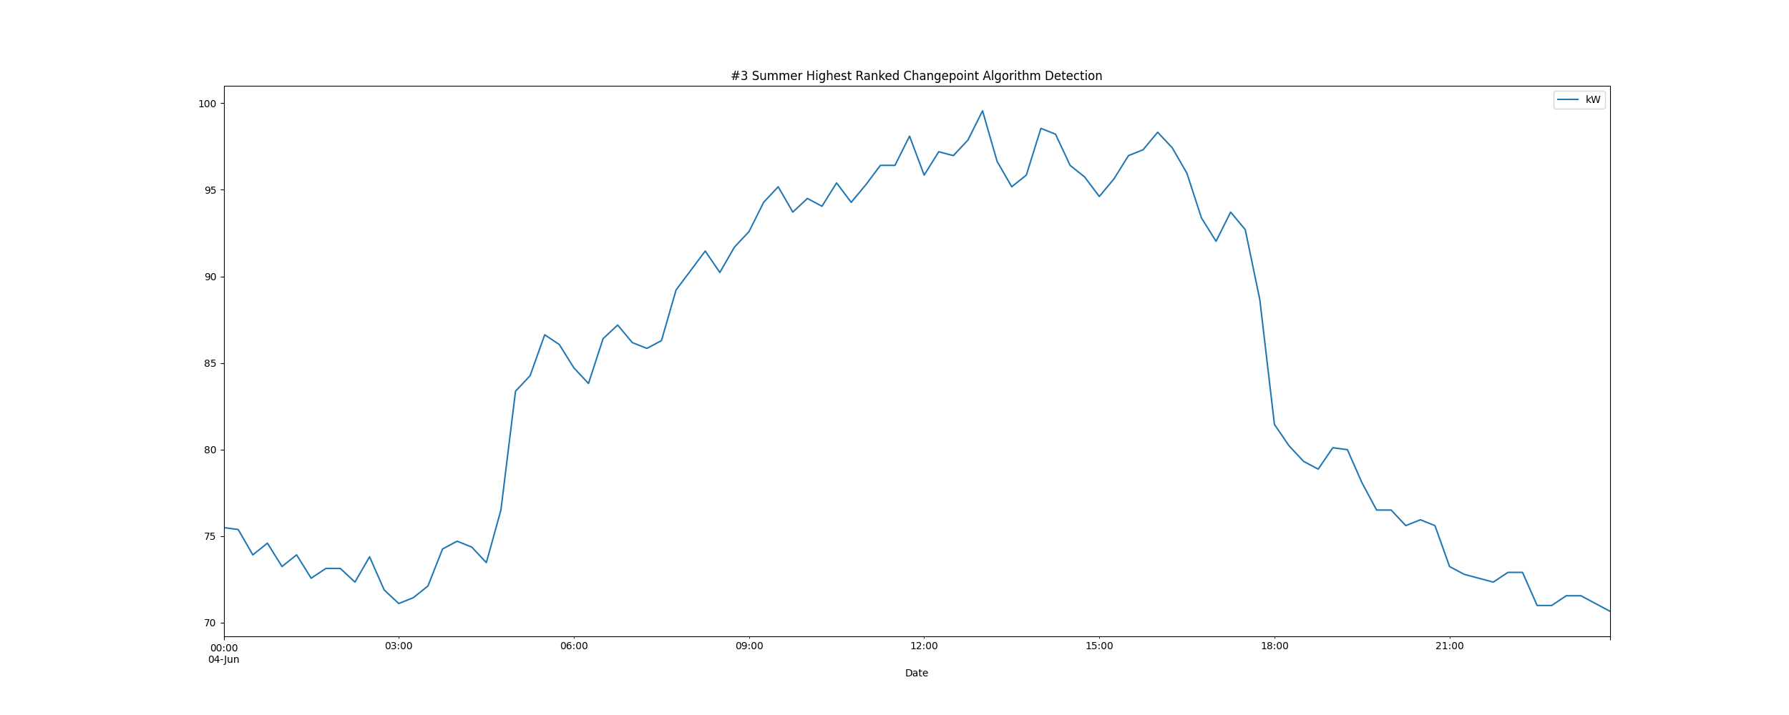

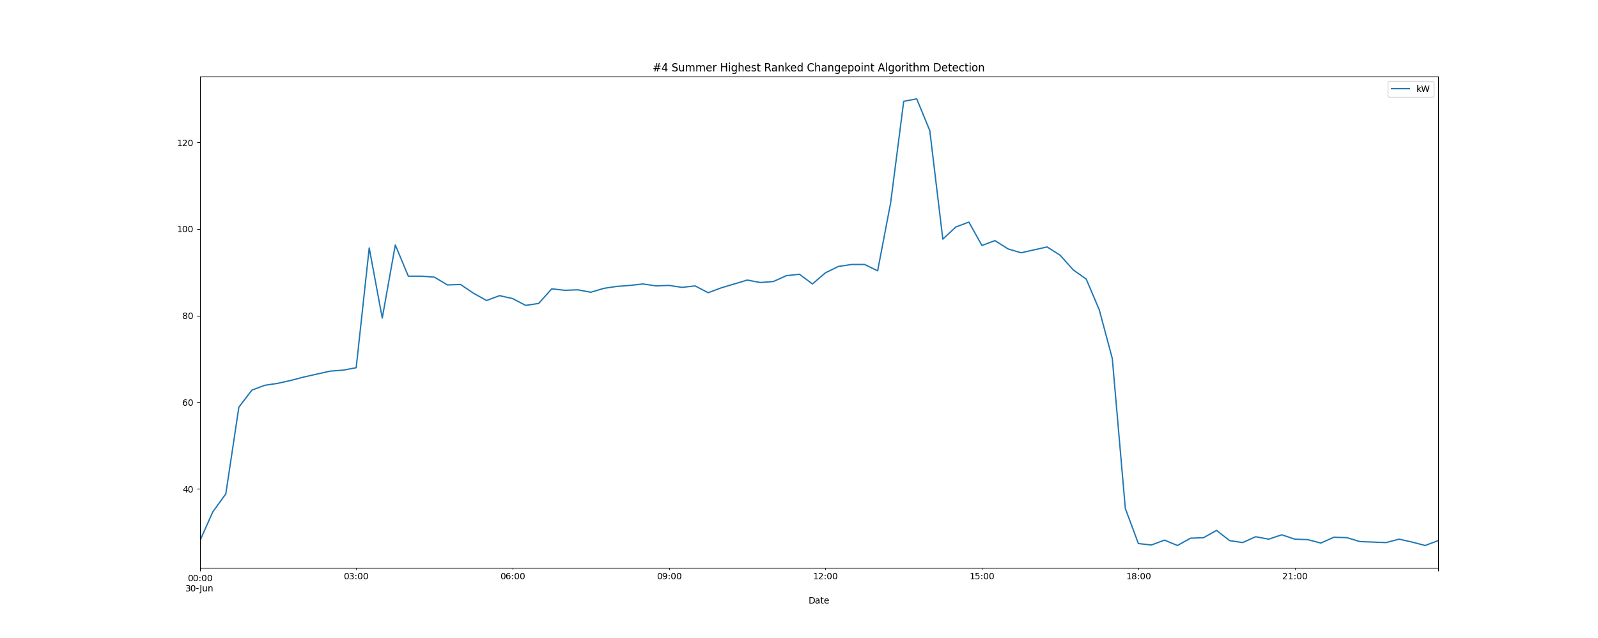

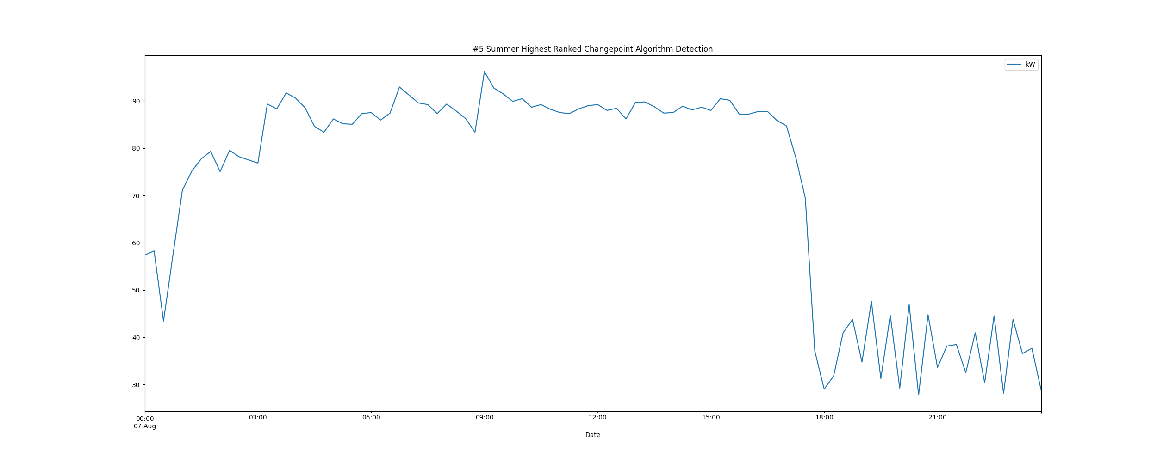

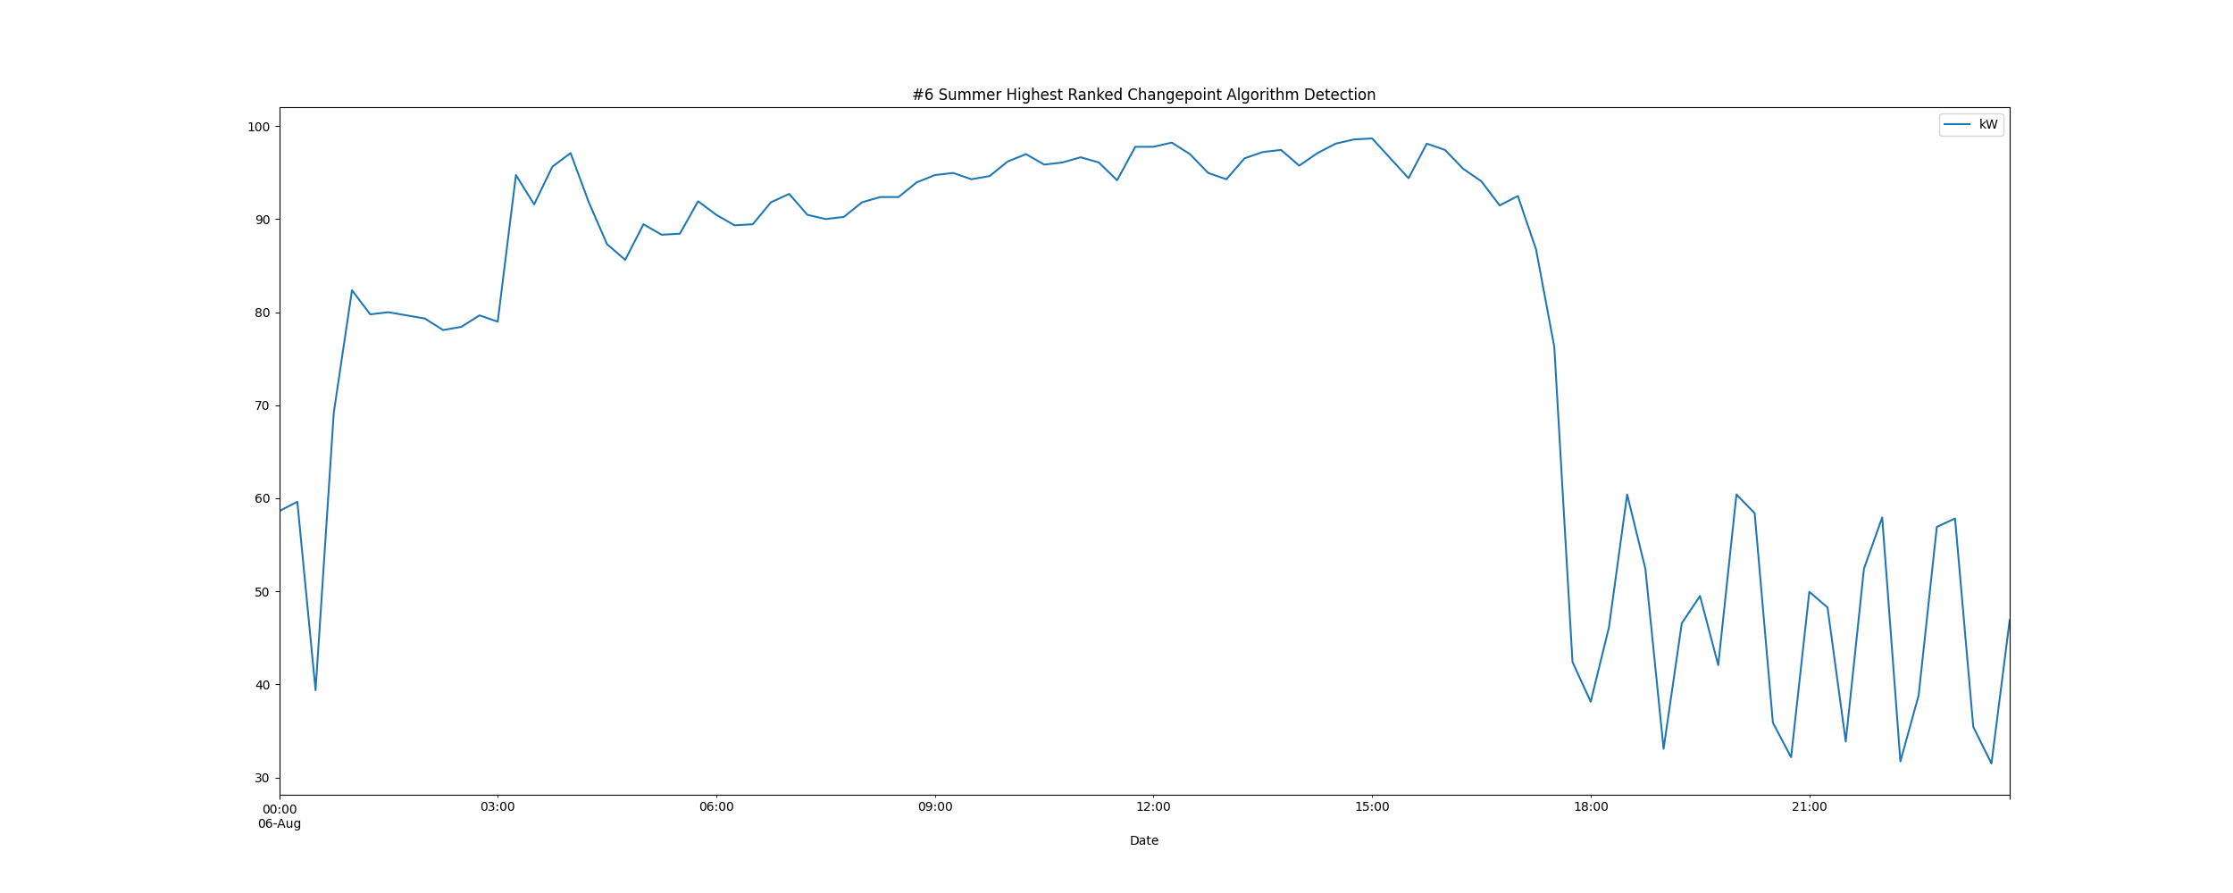

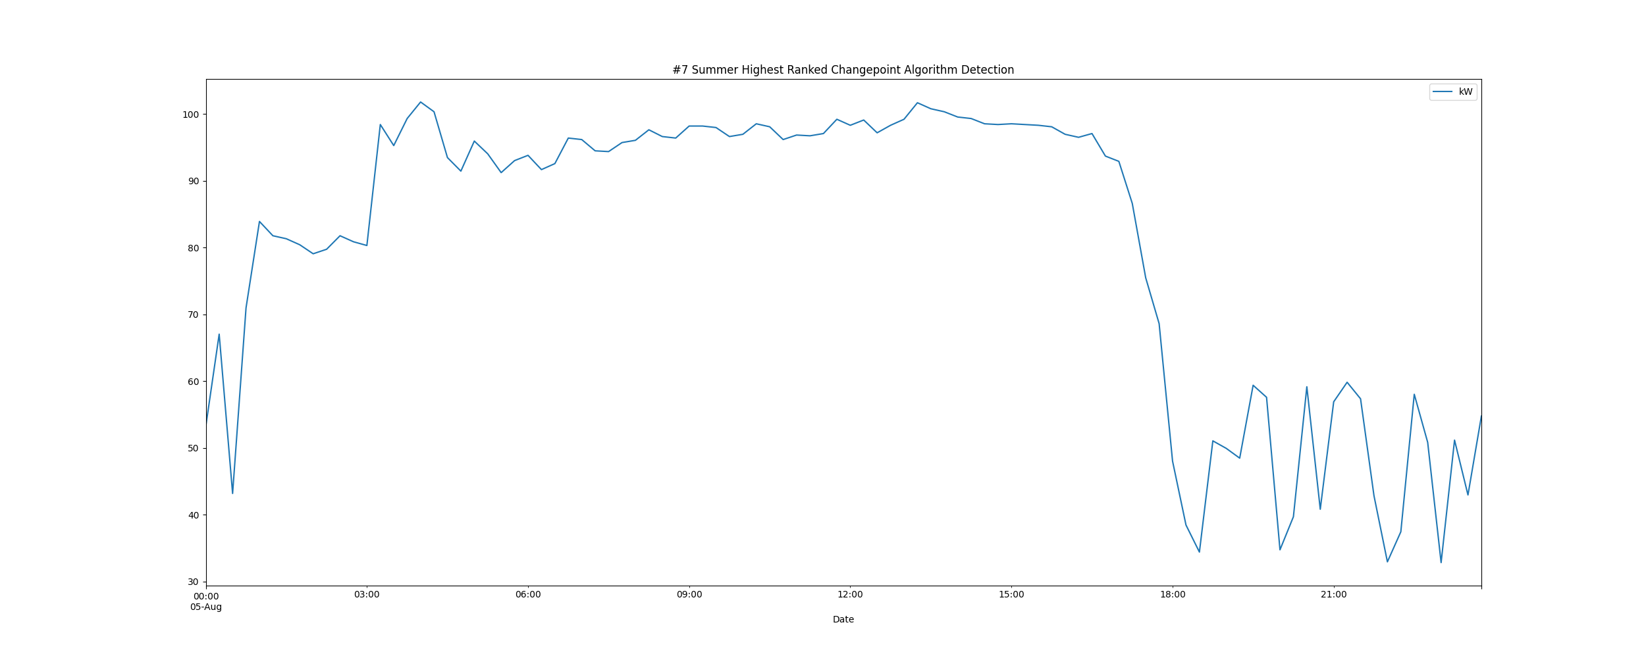

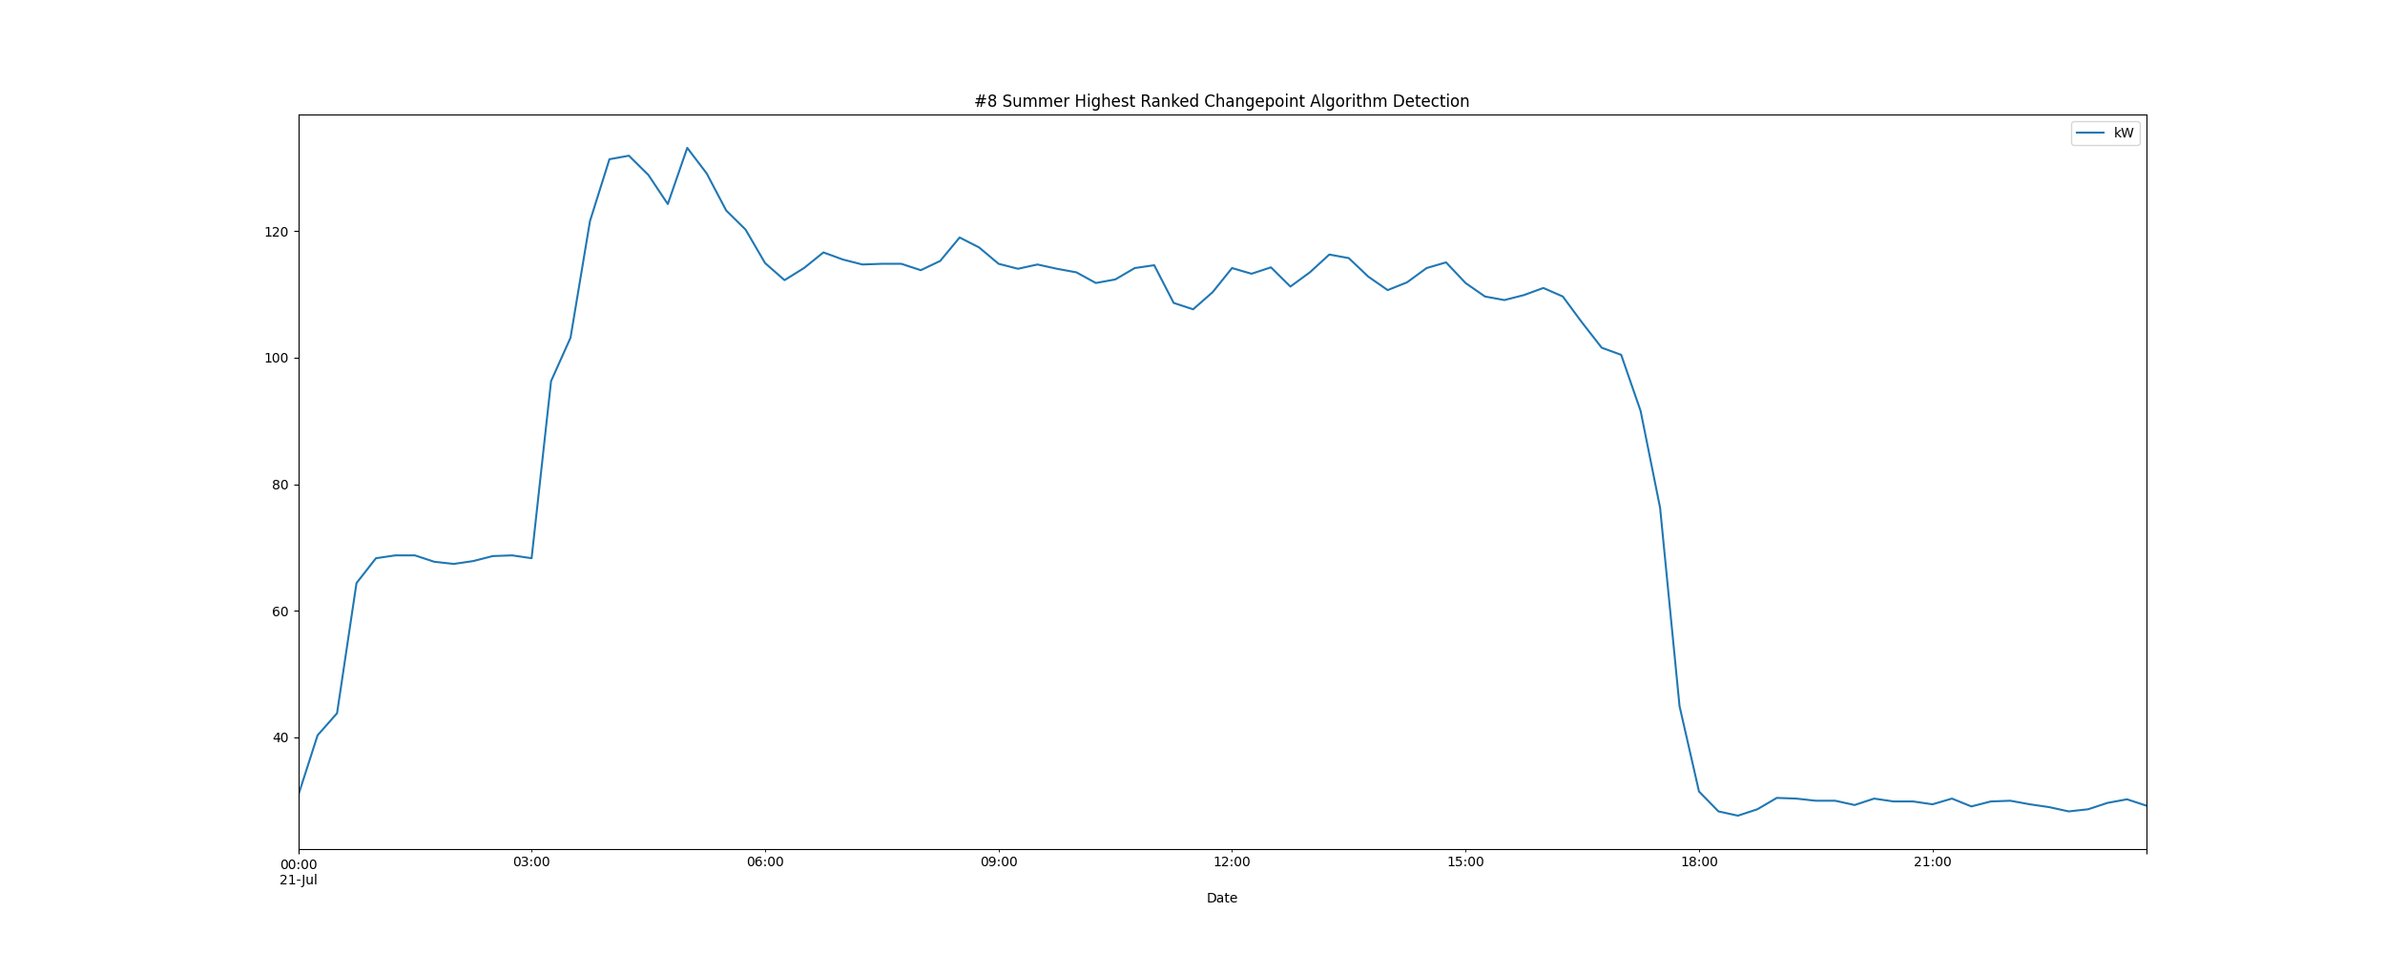

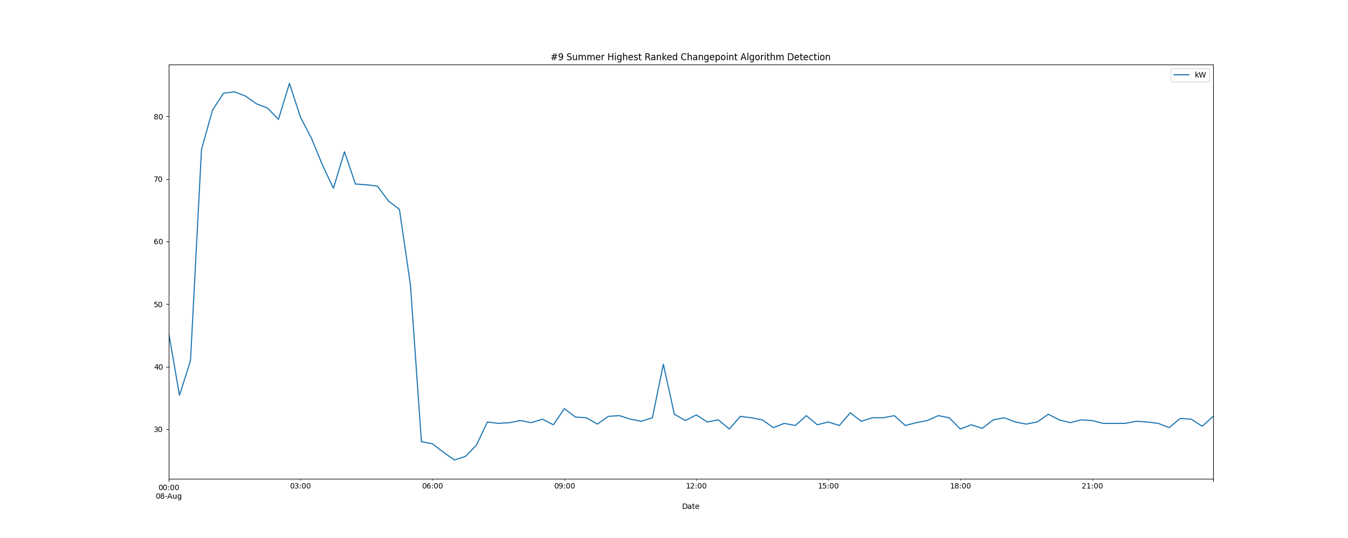

# Daily High and Low Load kW Values

highLowLoadsPlot.png

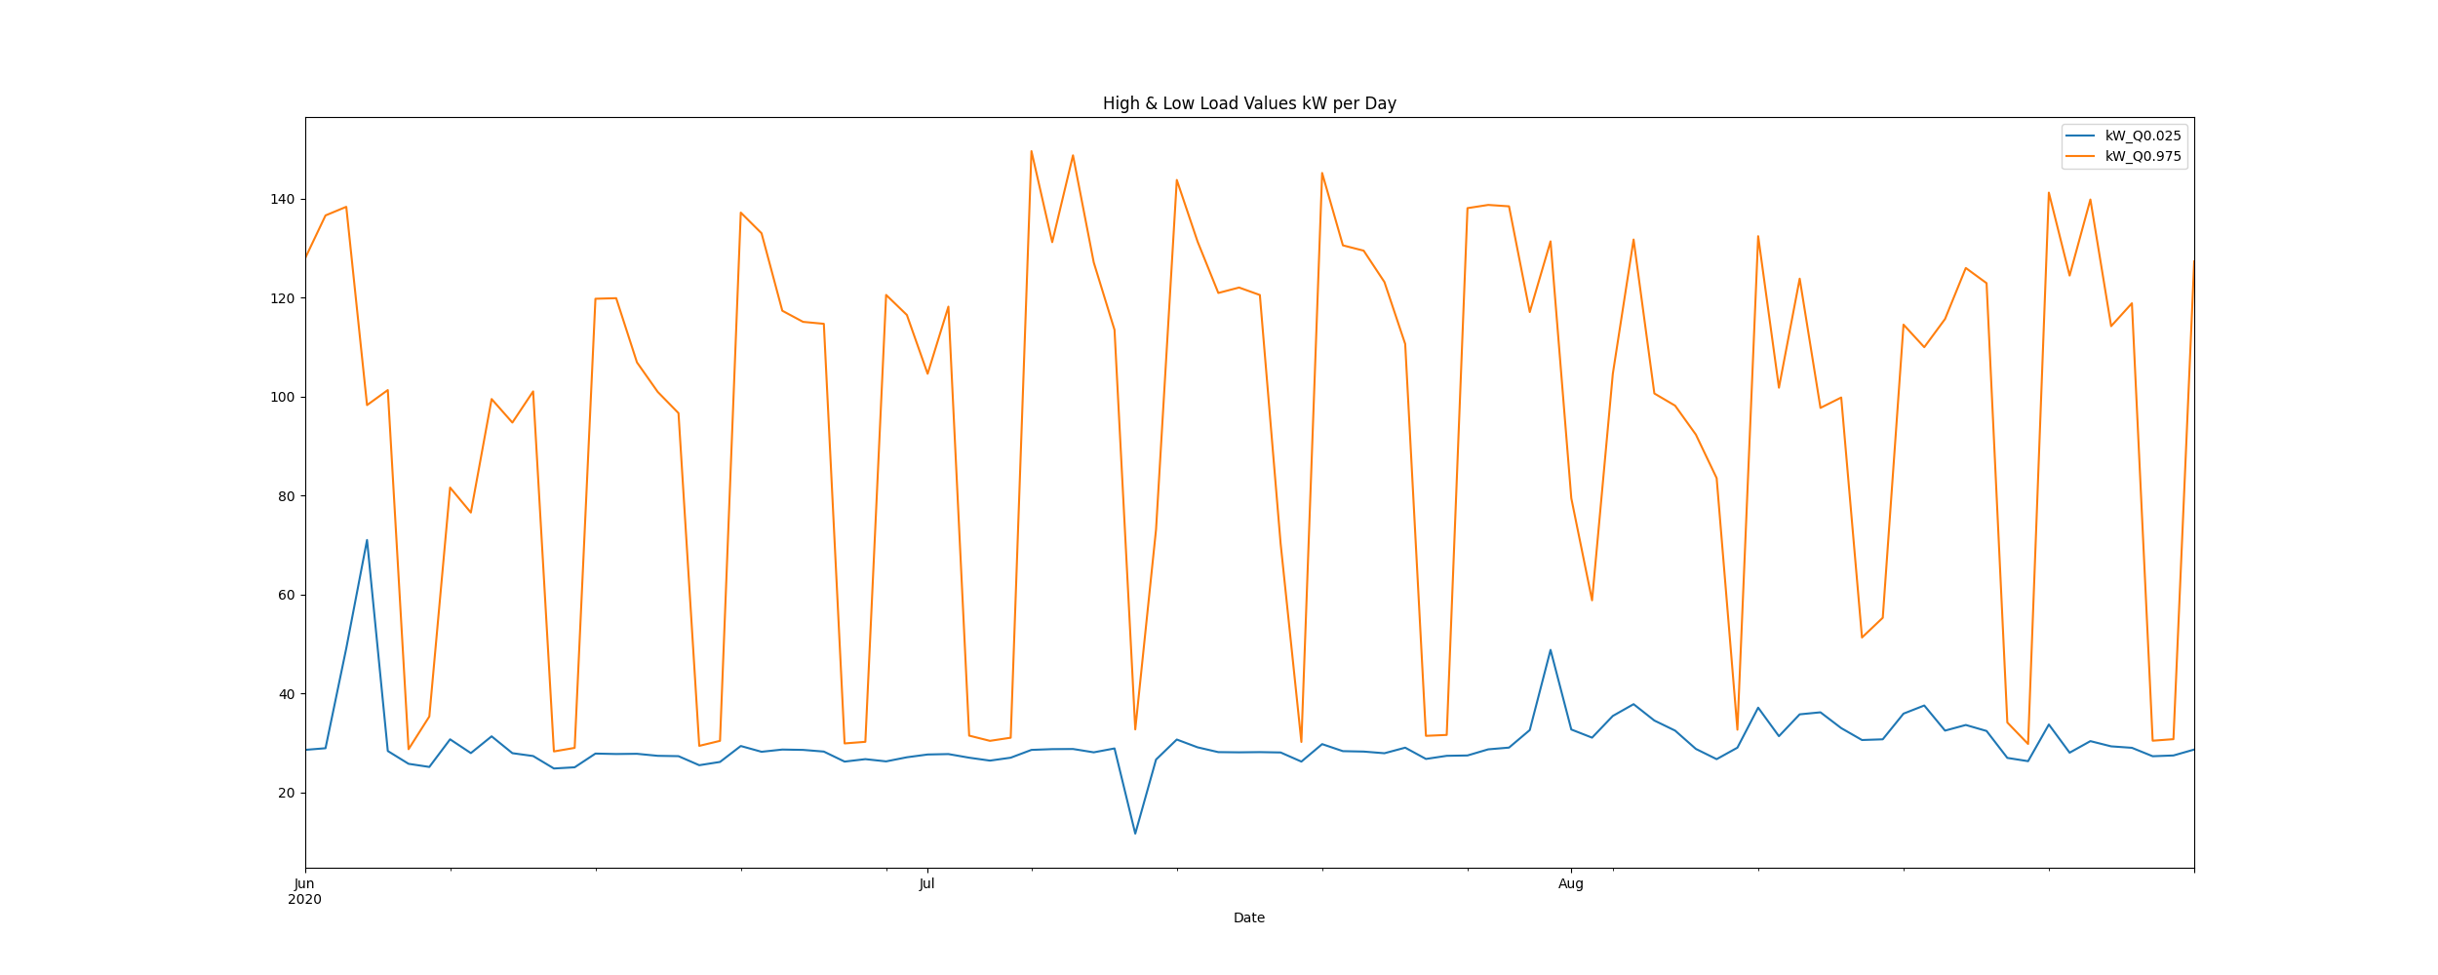

# Max Demand and Hour of Day Plot

Max_Demand_and_Max_Hour_of_Day.png

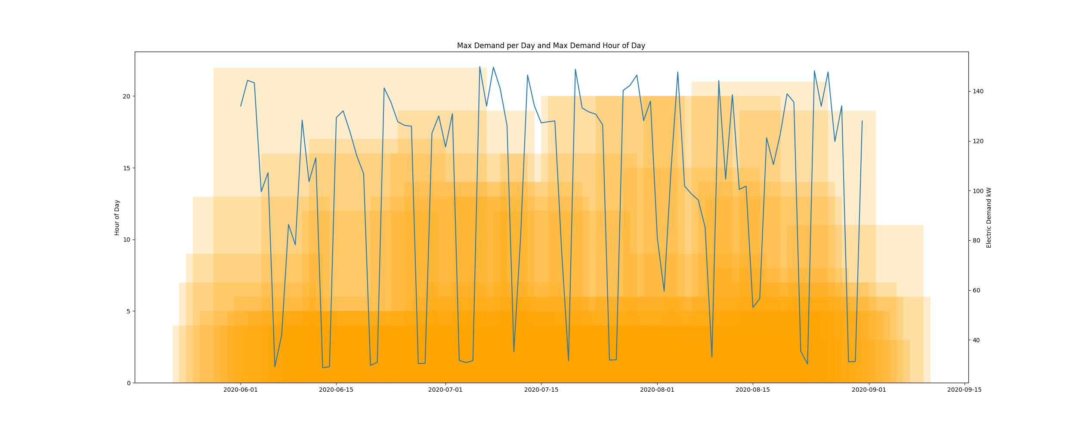

* Resampling the interval dataset to calculate units of energy KWh/day, the first day is 2020-06-01 and the last day is 2020-08-31
* Total days in dataset 91 days
* Total Sum of calculated electrical energy 143849.30474999998 kWh

# kWh Rolling 7 Day Avg

kWhRollingAvg.png

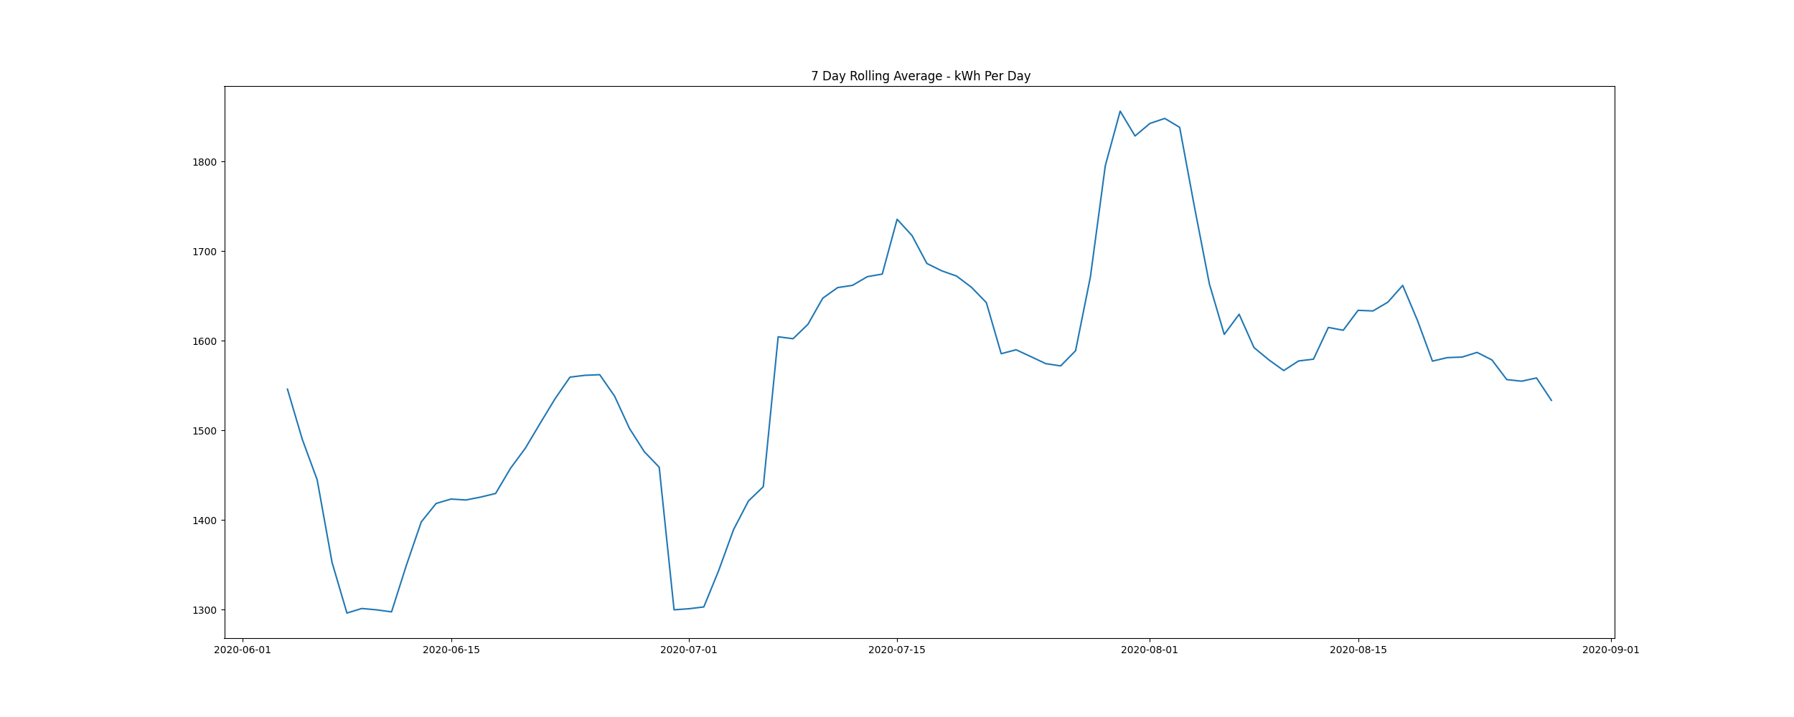

# Demand Plots By Month

Demands_for_Summer_Month_August.png

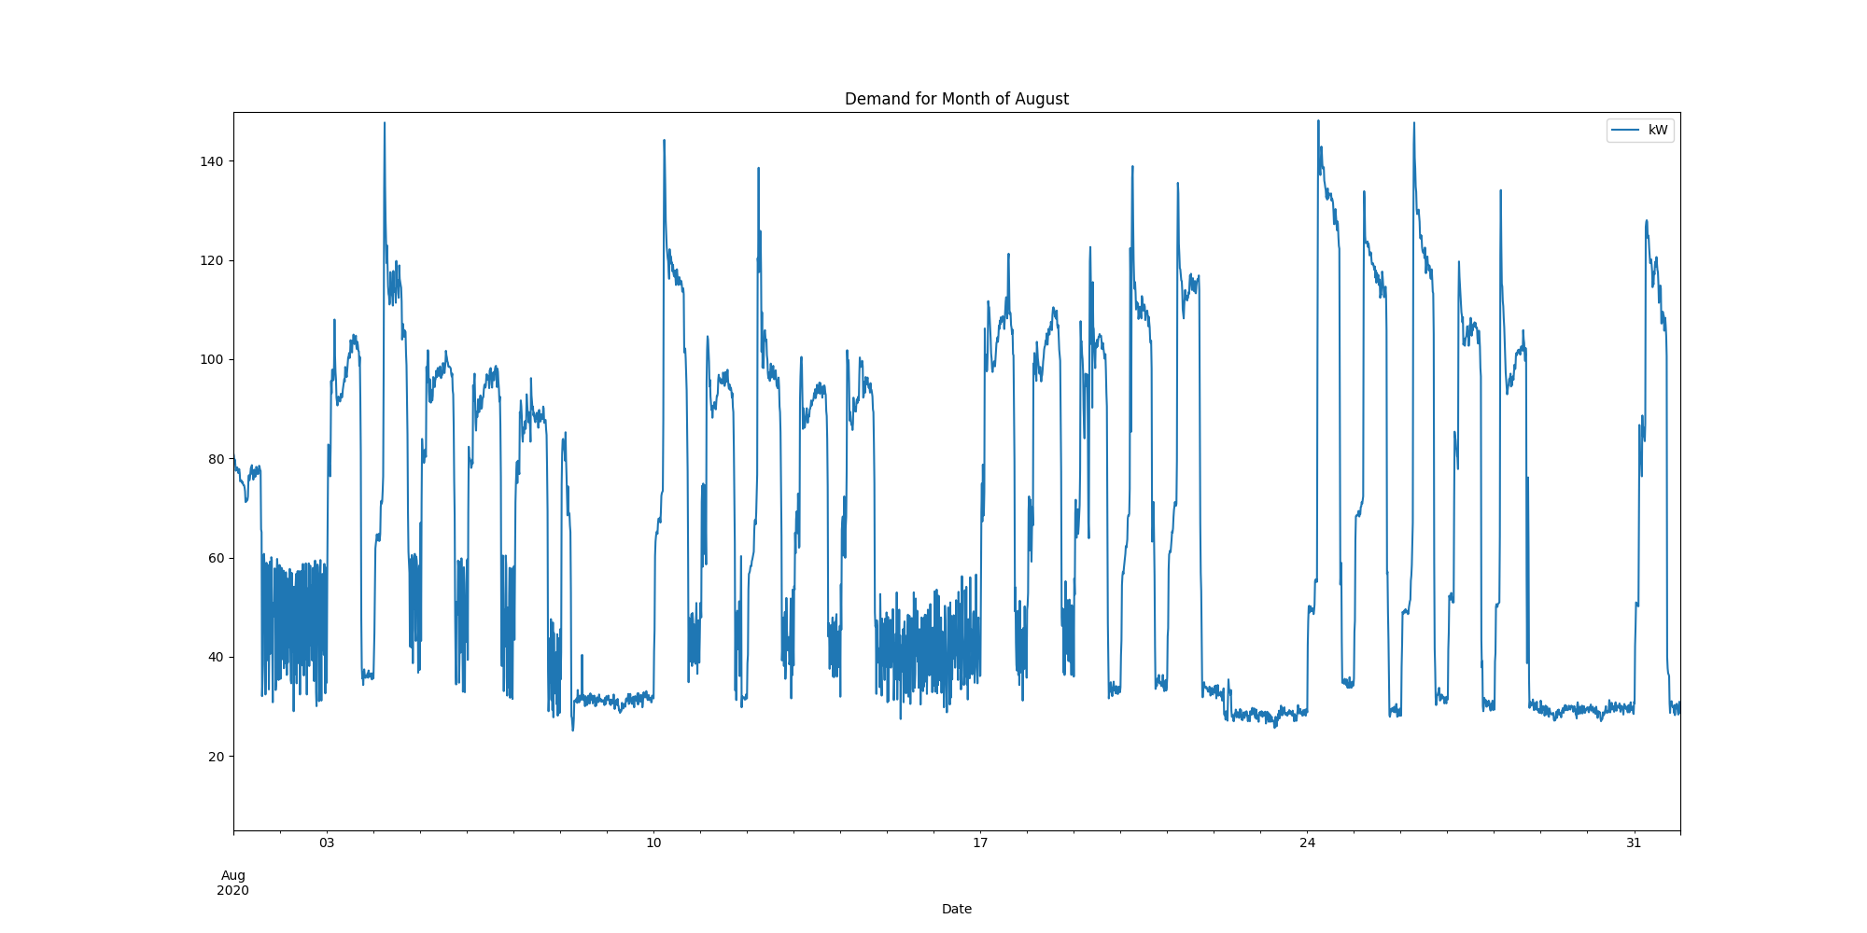

Demands_for_Summer_Month_July.png

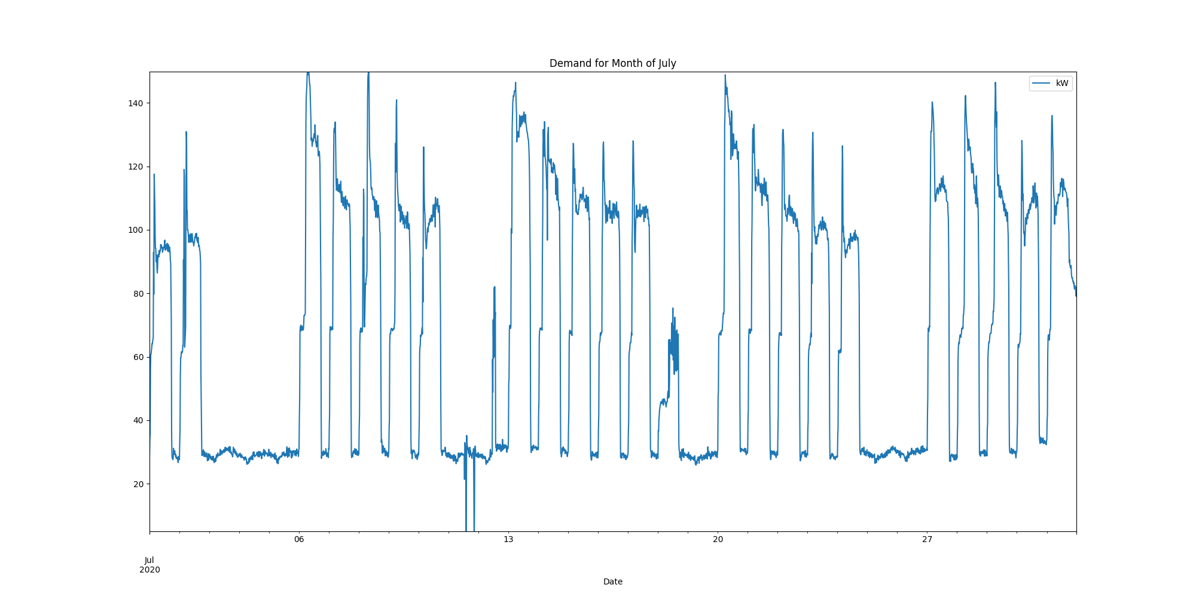

Demands_for_Summer_Month_June.png

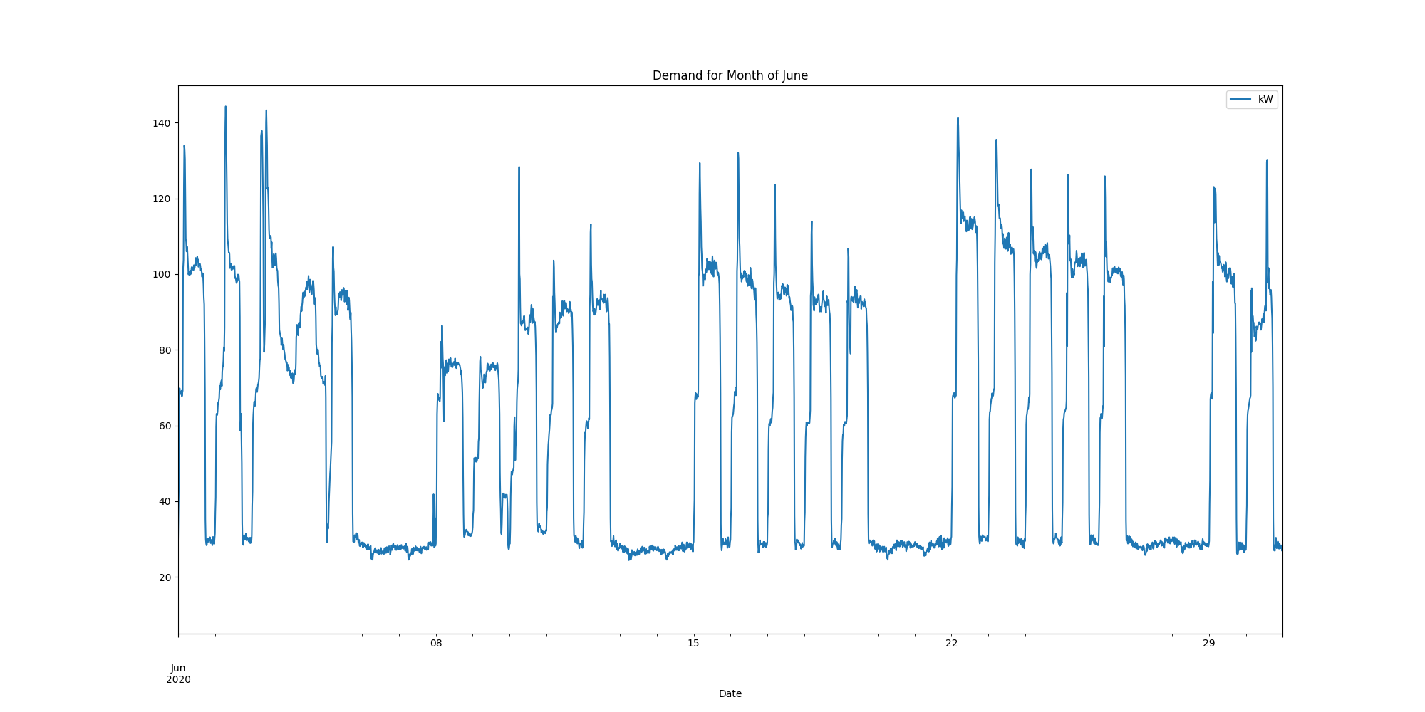

report compiled on:

08/04/2021 09:45:34